Sea Surface and Shoreline Visual Monitoring & Picture Log

Attachment C

Sea Surface Visual Monitoring & Picture Log

Date/Time | Initials of Observer | Discharge/  Mixing Zone Area | Feet in size. Beyond MZ Boundary Area? | Describe the location and amount of seafood waste, foam, film or sheen observed (estimated area) and the probable cause. | Number of ETS animals observed, including Steller sea lion, Steller’s eider, spectacled eider, northern sea otter, and short-tailed albatross. Note if injured or dead, and probable cause. | Tide cycle, (e.g., 2 hrs after high tide). | Monthly Picture (Date Stamp and photo number)

Name, Initials, Signature of Inspectors: ____________________________________________________________________________________
Name, Initials, Signature of Inspectors: ____________________________________________________________________________________
Name, Initials, Signature of Inspectors: ____________________________________________________________________________________

Comments: The operator must conduct daily sea surface monitoring while discharging to determine compliance with WQS, this permit conditions, and to document waste outside the mixing zone and onshore, observations of, or incidents involving, threatened or endangered species. A monthly photographic record must be maintained with each photograph given a unique identification number and matching description in this log. Clearly identify if animals observed are Steller sea lion, Steller’s eider, spectacled eider, northern sea otter, or short-tailed albatross. (Note if injured or dead and probable cause.)
 | 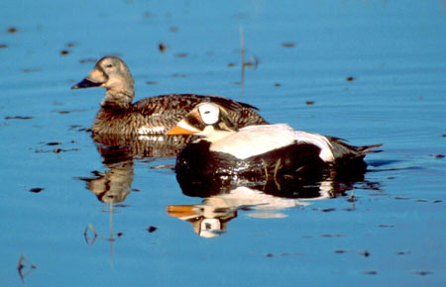
Steller’s eider | spectacled eider
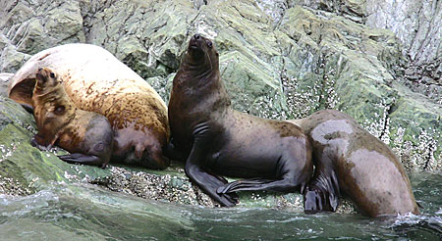 | 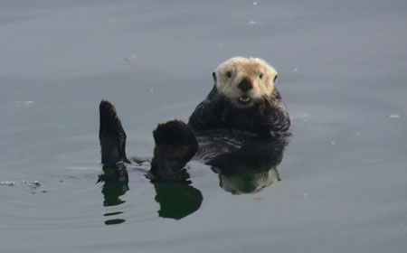
Steller sea lion | northern sea otter

short-tailed albatross

