
Takshanuk Watershed Council
P.O. Box 1029, Haines, AK 99827
(907)-766-3542

BEACH Monitoring
FY 2013 Final Report

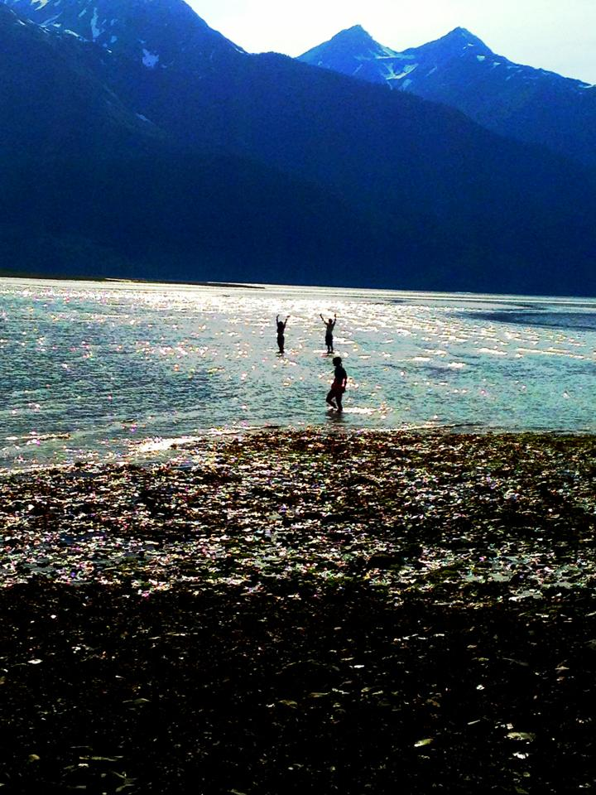

Prepared for:
Alaska Department of Environmental Conservation
Safe Swimming Beach Program
Project #: BEACH 13-B02

Executive Summary

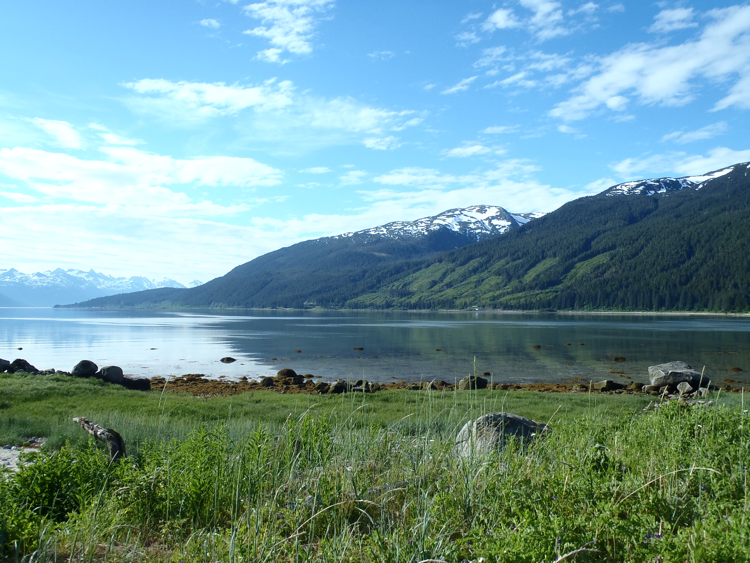
During FY 2013 the Takshanuk Watershed Council (TWC) and the Alaska Department of Environmental Conservation (ADEC) partnered to monitor the levels of harmful bacteria at swimming beaches in Haines, Alaska. With funding and guidance from ADEC the TWC monitored levels of Fecal Coliform and Enterococci on a weekly basis from July 2012 to August 2012 and May 2013 to June 2013. All of the samples were below the safe limit. In addition to the monitoring program, TWC also published sample results to the community through the quarterly newsletter and Facebook. Through these efforts with ADEC, the Haines community has become better aware of local water quality.

Introduction

Today, most beaches in Alaska are either not consistently monitored or not monitored at all, so visitors and residents face risks of illness from swimming and other activities in coastal areas that contain disease-causing bacteria.

The beaches of Haines offer a variety of water-related recreational activities such as, fishing, wildlife viewing, sea kayaking, kite-surfing, snorkeling, scuba diving, standup paddle boarding, swimming, and tide pooling. Beaches in and around Haines are also used for Haines Borough School District educational programs and field trips.

The water quality of many of the beaches in and around Haines are thought to be good, however, there is a lack of testing to confirm this. From this assumption there were two primary goals of the Haines Beach Monitoring Project. The first was to monitor bacteria levels at the most widely used recreational beaches (Portage Cove and Lutak Inlet) in the Haines Borough to gather data on the bacteria levels. The second was to increase public awareness of potential bacteria sources and the health risks associated with bacterial contamination.

Methods and Results

In June of 2011 the Takshanuk Watershed Council (TWC) and Alaska Department of Environmental conservation (ADEC) identified Portage Cove and Lutak Inlet beaches as the primary swimming beaches in the Haines Borough. Prior to beginning the sampling the ADEC BEACH Water Quality Monitoring and Pathogen Detection Quality Assurance Project Plan (QAPP) was revised for sampling in the Haines Borough (attached). At the beginning of FY2013 the QAPP and BEACH Monitoring Handbook (attached) were reviewed and it was found that the field blank requirement was deemed unnecessary by the DEC Program Manager so we removed this from the QAPP and Handbook.

In addition, a Memorandum of Understanding [(MOU), attached] was established between the Haines Borough and the Takshanuk Watershed Council outlining the roles and responsibilities of how to notify the public and limit access to the beaches in the case of an exceedence.

Portage Cove and Lutak Inlet beaches were sampled on a once a week basis from 7/5/2012 8/29/2012 and 5/8/2013 to 6/26/2013, during FY 2013. Samples at each beach were tested for Fecal Coliform and Enterococci. A field replicate was taken at one of the locations each week on a rotating basis. All of the samples were below the safe limits established by ADEC and the Environmental Protection Agency (EPA). See graphs.

Fecal Coliform Water Quality Standard
(Alaska Department of Environmental Conservation)
Single Sample | 200 fecal coliforms per 100mL
Geometric mean (average) of 5 samples within 30 days | 100 fecal coliforms per 100 mL
Enterococci Water Quality Standard
(Environmental Protection Agency)
Single Sample | 276 enterococci per 100 mL
Geometric mean (average) of 5 samples within 30 days | 35 enterococci per 100 mL

In addition to conducting the monitoring program, TWC also publicized sampling results in its quarterly newsletter and on its Facebook page. See article below.

Conclusion

During the sampling period from July 2012 to June 2013 the levels of harmful bacteria at Portage Cove and Lutak Inlet in Haines were below the safe level for recreational exposure, according to ADEC and the EPA.

For further information on the ADEC BEACH Monitoring Project, including a list of Alaskan communities that are part of this program, visit their webpage at: http://www.dec.state.ak.us/water/wqsar/wqs/beach_acwa1.htm

Appendix

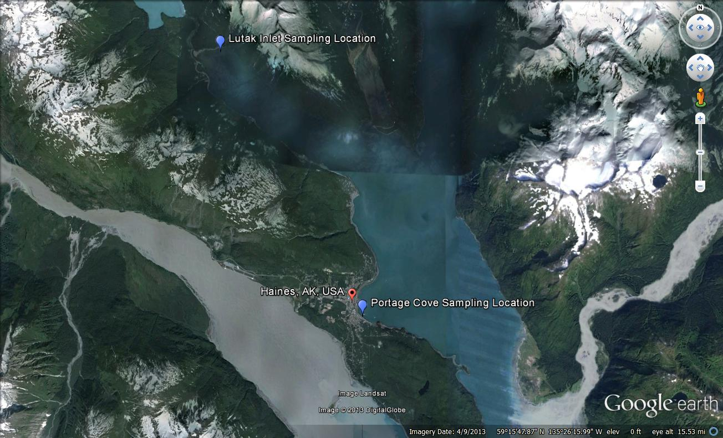
Appendix A: Overview of sampling locations

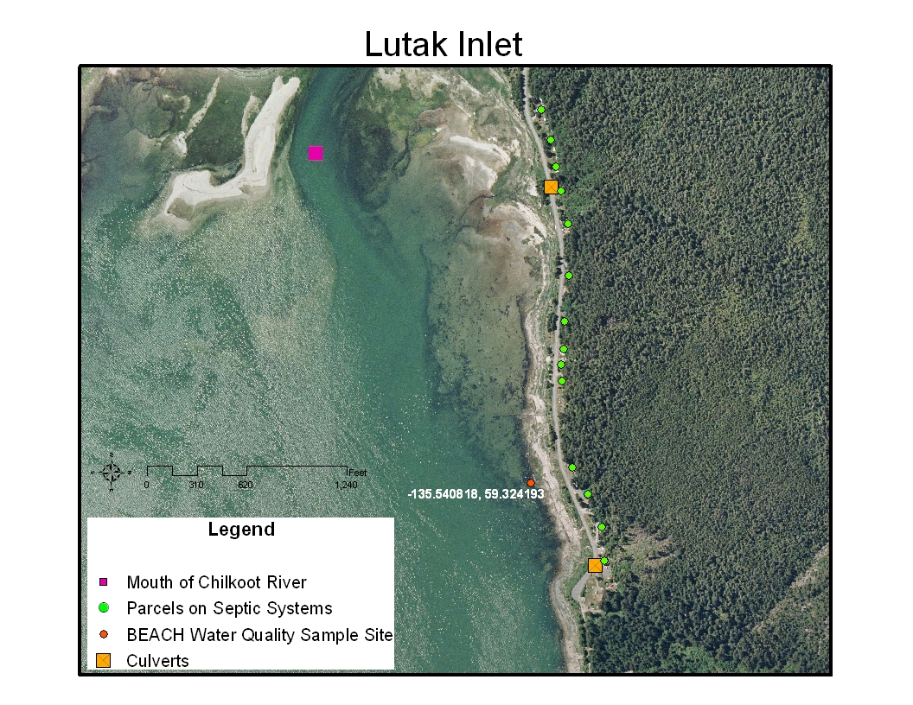
Appendix B: Map of Lutak Inlet with sampling location, septic systems, and culverts.

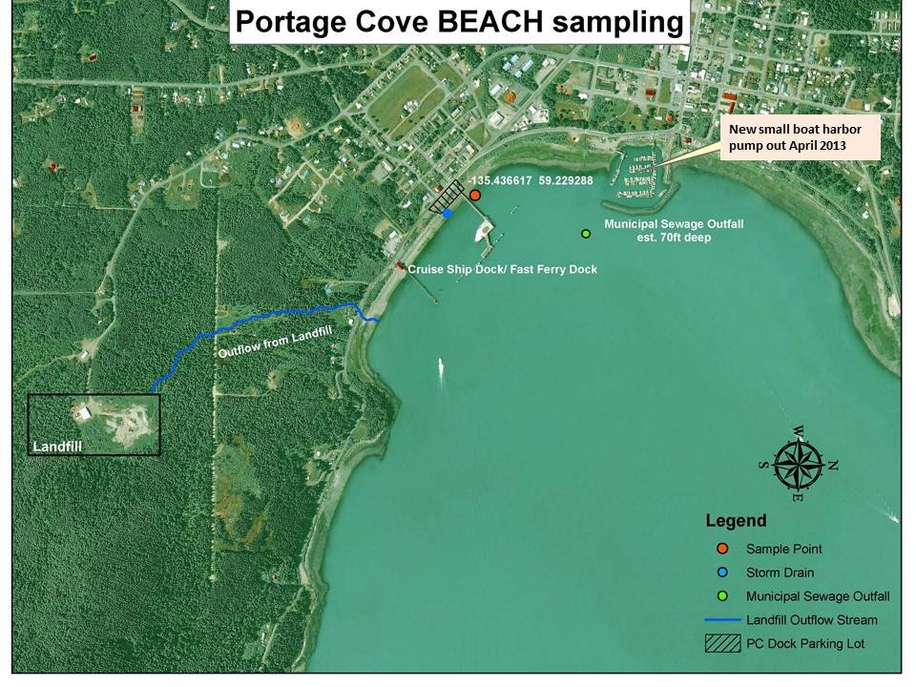
Appendix C: Map of Portage Cove sampling location, storm drains, municipal sewage outfall, and landfill outfall stream.

