Landfill Sign Question Walkthrough

Signs
Signs for solid waste are an important part of managing solid waste and recycling in your community. Signs could be placed at the landfill, recycling center, staging areas, recycling areas, trash cages/bins, bins for recyclable or collected material around town, etc. The questions below should be directed to a Landfill Operator, who actively works with the solid waste and recycling program. This person could also be known as the GAP Assistant, Waste Collector, Landfill Laborer, Heavy Equipment Operator, or any combination of these terms. A Council member or Administrator may not have sufficient hands-on knowledge of the program to know what is needed and what might be needed in the future.
The village of Circle used Chalkyitsik’s sign proofs, and the questions below to create a sign order that was specific for them. All proofs have spelling errors. You must check every one for every community prior to approving! Sign proofs are on the following pages.
There are also regulatory required signs and language. See the table below for what’s required.

Signage | A clearly legible sign must be posted at the entrance to the landfill. The sign must prohibit disposal of regulated hazardous waste and polychlorinated biphenyl (PCB) waste. Signs should identify the owner or operator, hours of operation, and emergency contacts. Signs should also direct users where to dispose of special wastes. 18 AAC 60.240
Signage | No signs at the landfill | Signs in poor condition, unreadable | Basic information on where to dump waste and/or entrance sign | Basic information on where to dump waste and list of prohibited waste and/or entrance sign | Direction where to dump waste, list of prohibited waste, entrance sign, and burning instructions (if applicable) | Detailed direction where to dump waste, list of prohibited waste, complete entrance sign, burning instructions, and alternative disposal methods

Questions you should answer in sequence order:

- What signs do you have?
- What are they made of?
- Are there any signs that you wish you had?

Landfill-Specific
- What signs do you have at your landfill?
- What materials do you take at your landfill?
- Do you have an entrance sign? Does it include the regulatory required information (mentioned above)?
- Do you have a prohibited waste and/or accepted waste sign? Does your prohibited waste sign include Hazardous Wastes and PCB’s? See Prohibited Waste on the entrance signs for examples.
- Do you need to direct users to different parts of the community for prohibited materials? Do you need a sign(s) to direct where to take the materials to instead? See Directional Signs on last page for example.
- Do you have any local policies that would require their own sign or is there anything landfill related that should have its own sign? For example, in high wildfire risk areas in the interior, landfill burning is prohibited from April to October. Or do you have a Construction and Demolition Debris form that needs to be filled out prior to accepting the material, or is there a number for contacting the Operator outside of operating hours for a call-out fee, etc.
- Do you have any problem areas that need their own sign? Examples are signs that say, “No Open Burning on The Ground”, “It Is Illegal To Leave A Car Here”, ‘No Dumping”, etc.
- Do you sort waste at the landfill, such as separate areas for trash, vehicles, construction waste, etc.?
  - If there is no sorting: Do you think if you had signs for sorting waste that it would help you keep the landfill more organized?
  - If there is sorting: If you already sort waste at your landfill- if you had signs for them, are there more categories you would use? Examples of materials that villages have used signs for are: tires, metal, scrap metal, vehicles, drums, wood, paint, wire, wood longer than 4 feet, aluminum, plastic bottles, electronics, other plastic, burnables, non-burnables, fish nets, ATV’s, snowmachines, propane cylinders, white goods, and just about anything else you can think of (see real community examples below).

Recycling Materials / Sorting
- Do you accept recyclables in other places in the community? If so, what materials? At how many locations? Does each location need signs for each material? Examples of materials that can be recycled: white goods, scrap metal, aluminum cans, pop bottles, ink cartridges, electronics, lead acid batteries, clothes, household batteries, light bulbs – tube and compact, aerosol cans, paint.
- Do you have a recycling center? Do you need signs for things you collect in different cabinets? For example, HHW or Household Hazardous Waste, Aerosol Cans, Fuel, Spill kit, Paint, Acid, Bases, Flammables….
- If you do recycle, are there materials you’d like to recycle that you currently don’t in your community? Do you need a sign for that for the future? Is it possible that you will have multiple collection sites or bins for that material? For example, once aluminum can recycling takes off, some places needed 4 signs just for aluminum cans.
Sign Materials / Location
- For all signs- only signs that will be outdoors will need the reflective coating, so it is easily visible in the winter from headlights shining on them. Which of the signs we’ve discussed today will be located outside? Any sign that will be inside of a building, recycling connex, or in a place that will not be drivable does not need this special coating.
- For all signs: which signs can be small, 12”x18”, and which signs should be the large signs, 24”x48”? We use the default sizes if we can because any coating or cutting makes the signs more expensive. You will see in the example sign examples from rural Alaska, that they use the same default sizes.
- Now that we know what signs will be outside, we need to determine how they can be hung. If you need an entrance sign, is there fencing or a gate to hang it on? Do you need posts, cement or supports for free standing signs in the landfill? How tall? If you plan to use tires with rims to cement sign posts in to create moveable but stable signs, do you have enough tires and rims for all the moveable signs you need? If you plan to install signage on fencing, what supplies do you need to do this- metal wire, bolts, links, etc.?

Note: All quoted costs on the examples below are from 2022. For current pricing, contact your preferred sign company.

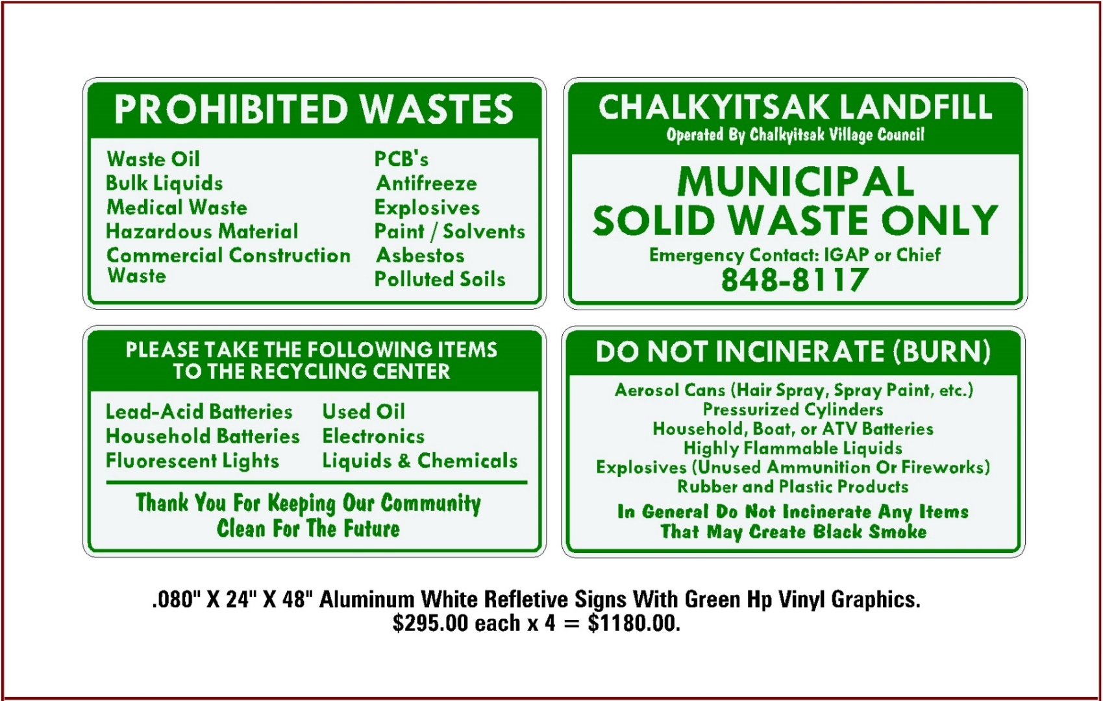
Chalkyitsik Entrance Sign

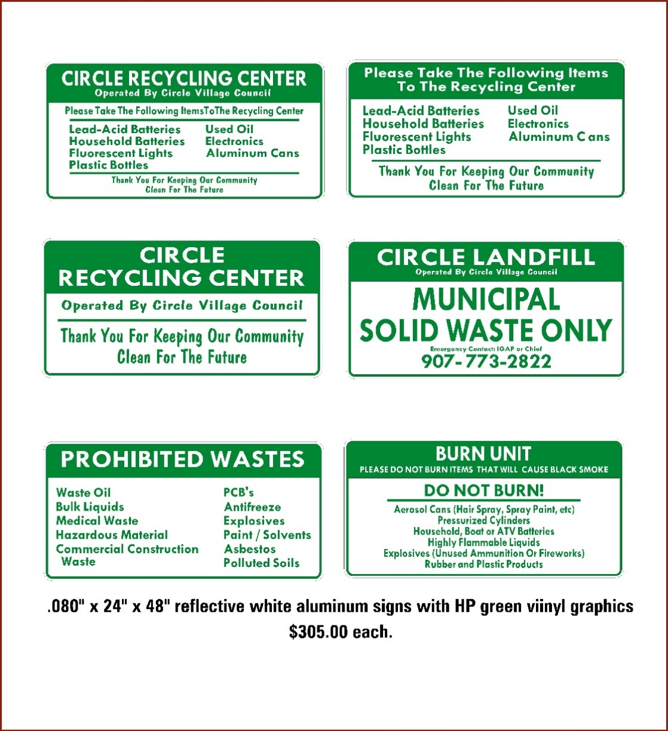
Circle Entrance Sign
Sorting Signs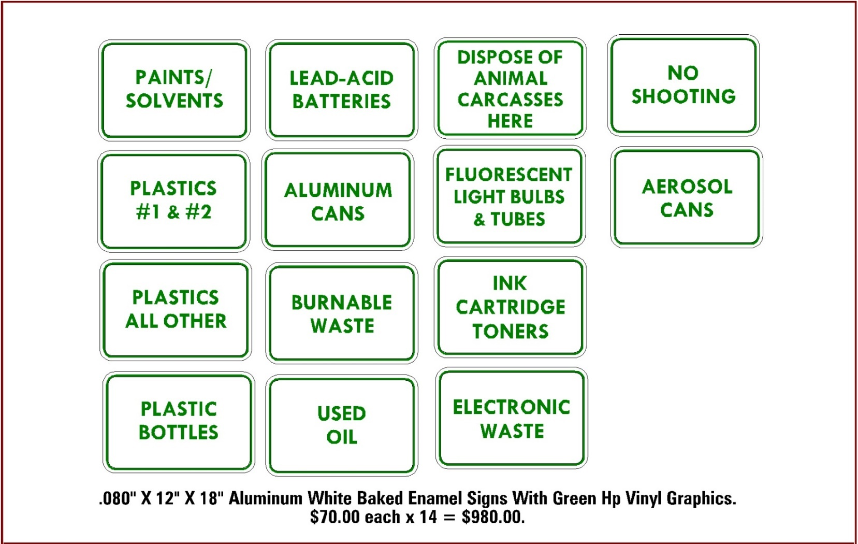

Sorting Signs

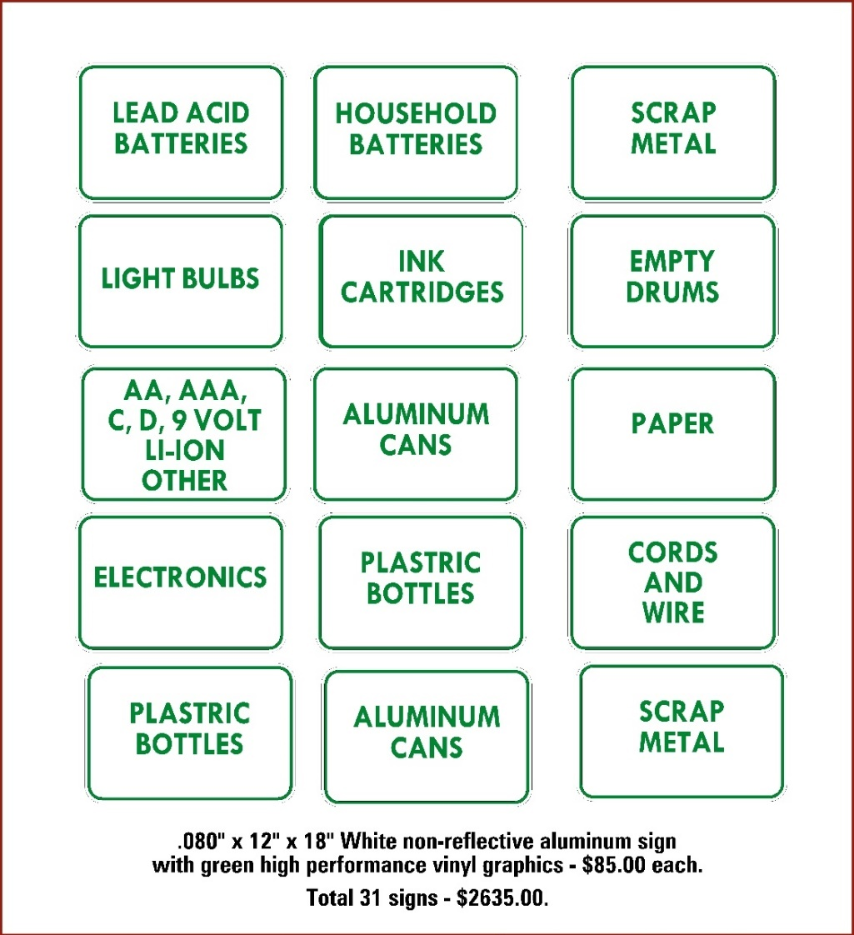
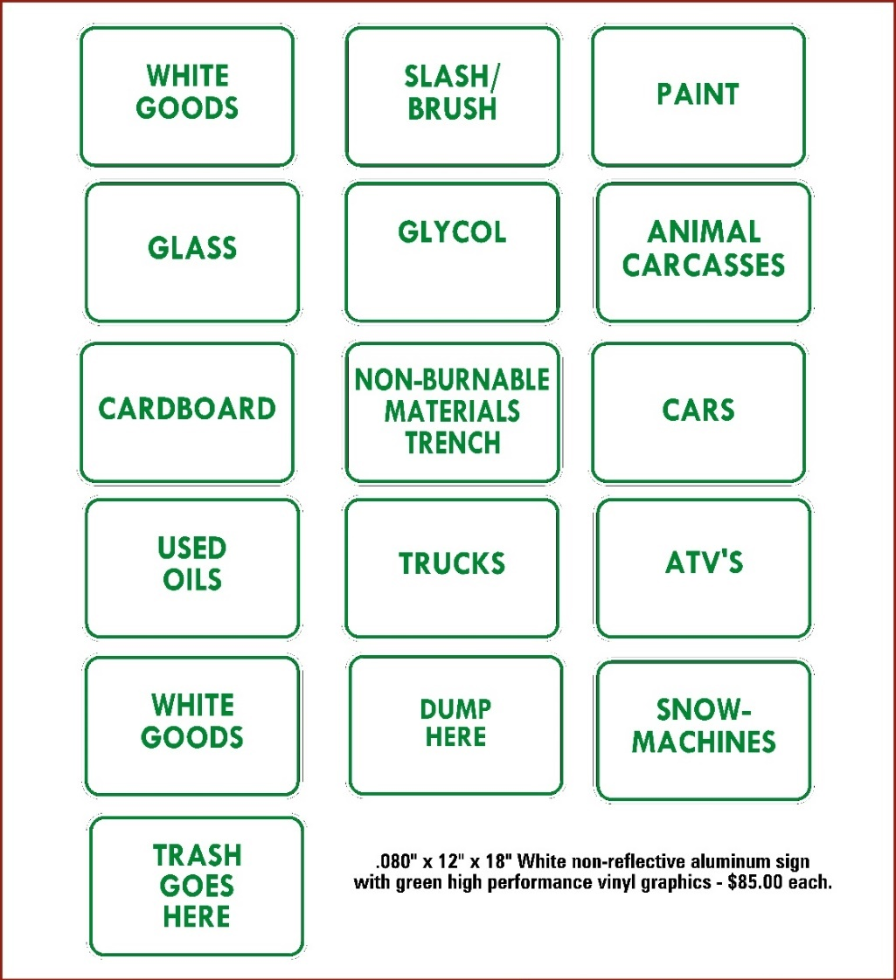
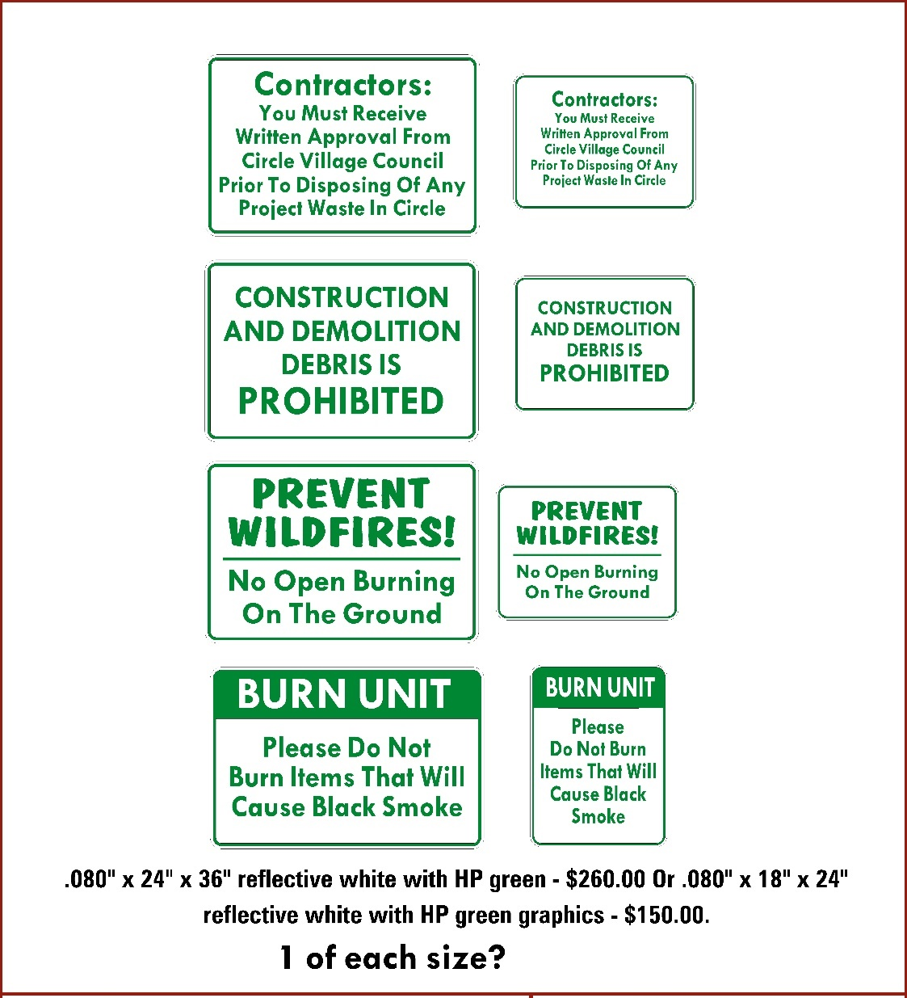
Problem Areas / Burning Instructions

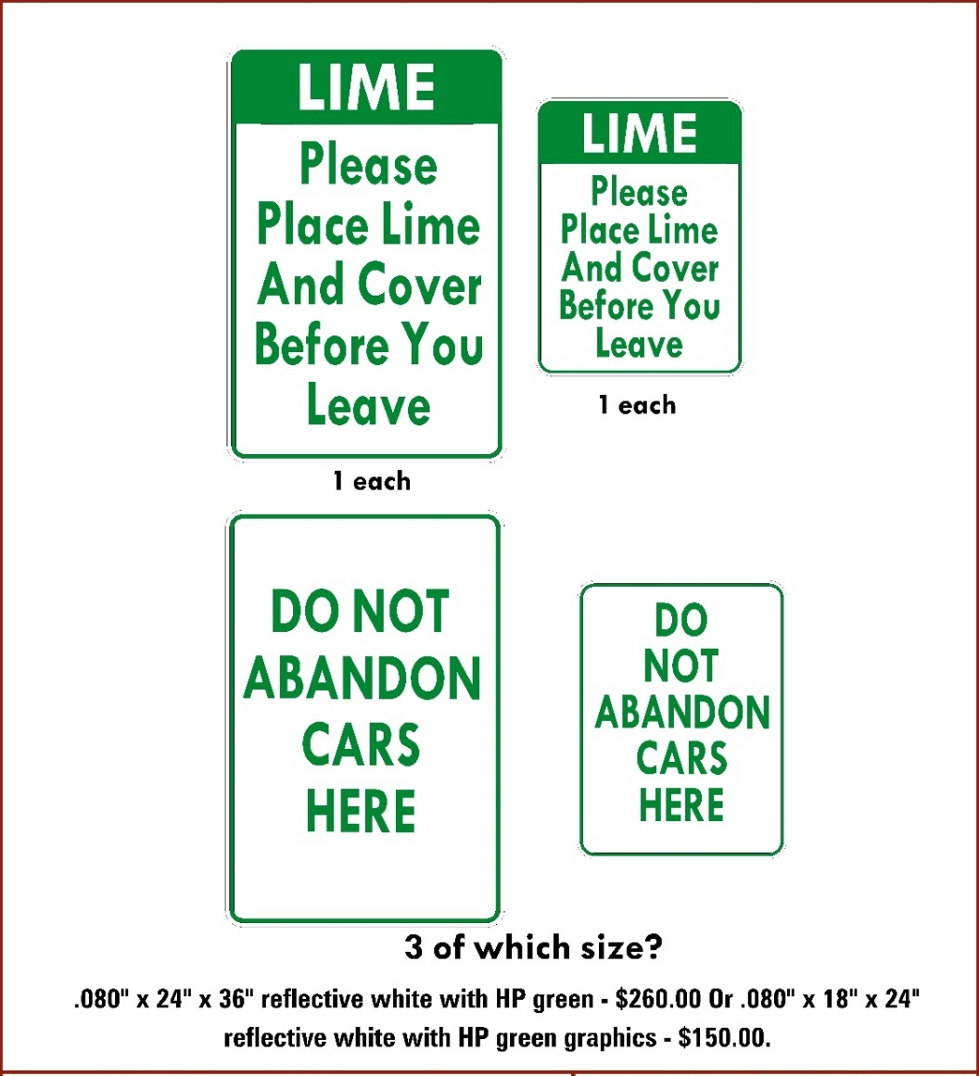
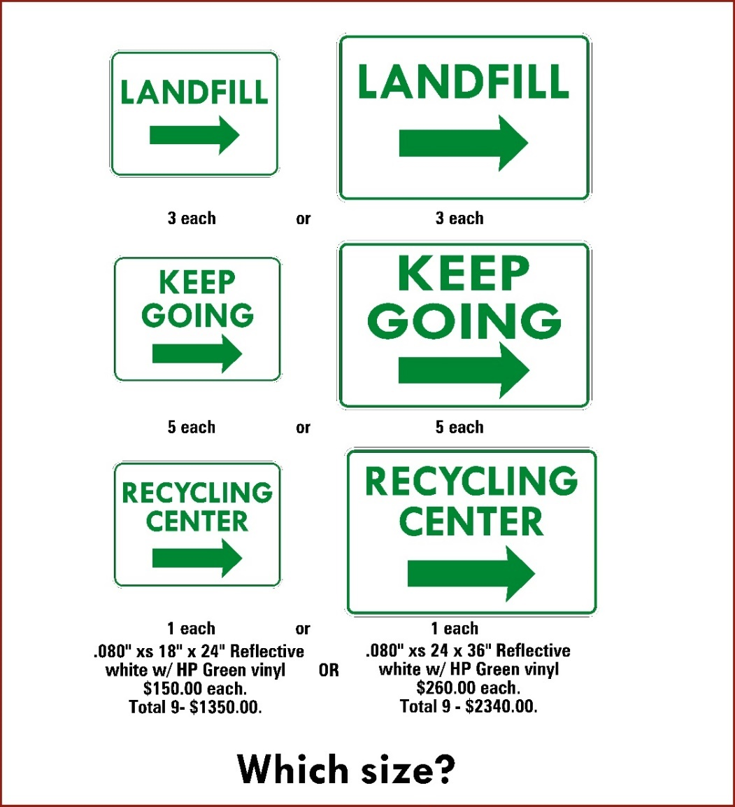
Directional Signs

