GENERIC SMALL CPV TEMPLATE

Quality Assurance Project Plan
for
Sampling and Analysis of Treated Sewage and Graywater from
Small Commercial Passenger Vessels

Insert Vessels covered by this QAPP here

Prepared by
Alaska Department of Environmental Conservation

Prepared for
Small Commercial Passenger Vessels

March 2025
Effective March 1, 2025 – March 1, 2028

Submitted to fulfill requirements of
18 AAC 69.025



PROVIDED AS A TEMPLATE, IF USING THIS GENERIC QAPP,
ITEMS MUST BE VERIFIED (SIGNED OFF BY VESSEL PROJECT MANAGER AND PROJECT QA OFFICER).
Return Final Draft to ADEC for Approval/Signatures.

Approvals Signature (required prior to project start):

____________________________________ Date: ___________________
Owner/Operator

____________________________________ Date: ___________________
Project Quality Assurance Manager

____________________________________ Date: ___________________
Sampling Manager/Team Leader

____________________________________ Date: ___________________
ADEC QA Officer

____________________________________ Date: ____________________
ADEC Program Manager

Table of Contents
Table of Contents 3
1.0 PROJECT MANAGEMENT 5
1.1 Title and Approval Page 5
1.2 Table of Contents 5
1.3 Distribution List 5
1.4 Project Organization 6
1.5 Problem Definition/Background 8
1.6 Project/Task Description and Schedule 10
1.6.1 Project Description 10
1.7 Quality Objectives and Criteria for Measurement Data 12
1.7.1 Objectives and Project Decisions 12
1.7.2 Action Limits/Levels 12
1.7.3 Measurement Performance Criteria/Acceptance Criteria 12
1.8 Special Training Requirements/Certification 20
1.9 Documents and Records 22
1.9.1 QA Project Plan Distribution 22
1.9.2 Field Documentation and Records 22
1.9.3 Laboratory Documentation and Records 23
1.9.3.1 Final Reporting Deadlines 24
2.0 DATA GENERATION AND ACQUISITION 24
2.1 Sampling Design 24
2.2 Sampling Methods 28
2.3 Sample Handling and Custody 29
2.4 Analytical Methods 33
2.4.1 Field Measurements Methods 34
2.4.2 Laboratory Analyses Methods (Off-Site) 34
2.5 Quality Control Requirements 35
2.5.1 Field Sampling Quality Control 35
2.5.2 Field Measurement/Analysis Quality Control 35
2.5.3 Laboratory Analysis Quality Control 36
2.6 Instrument/Equipment Testing, Inspection, and Maintenance 36
2.6.1 Field Measurement Instruments/Equipment 39
2.6.2 Laboratory Analysis Instruments/Equipment (Off-Site) 39
2.7 Instrument/Equipment Calibration and Frequency 39
2.7.1 Field Measurement Instruments/Equipment 39
2.7.3 Laboratory Analysis Instruments/Equipment (Off-Site) 40
2.8 Inspection/Acceptance Requirements for Supplies and Consumables 40
2.8.1 Field Sampling Supplies and Consumables 40
2.8.2 Laboratory Analyses (Off-Site) Supplies and Consumables 40
2.9 Data Acquisition Requirements (Non-Direct Measurements 40
2.10 Data Management 41
3.0 ASSESSMENT AND OVERSIGHT 42
3.1 Assessments/Oversight and Response Actions 42
3.1.1 Field Assessments 42
3.1.2 Laboratory Assessments 42
3.1.3 Replicates 42
3.1.4 Corrective Action 42
3.2 Reports to Management 42
4.0 DATA REVIEW AND USABILITY 43
4.1 Data Review, Verification, and Validation Requirements 43
4.2 Verification and Validation Methods 43
4.3 Reconciliation with User Requirements 44
5.0 REFERENCES 45
APPENDIX A. Sampling checklist 46
Appendix B - Alaska Small Cruise Ship Data Review Checklist 47
Appendix C – QAPP Deadlines* 48
Applications: 48
Notifications: 48
Analytical Reports: 48
Audits 48
Reporting: 48

1.0 PROJECT MANAGEMENT

1.1 Title and Approval Page - See page 1

1.2 Table of Contents - See pages 2 - 4

1.3 Distribution List

Name: Vessel Contact
Title: Project Manager
Organization:
Contact Information:

Name:
Title: Cruise Ship Program Manager
Organization: Alaska Department of Environmental Conservation
Contact Information:

Name:
Title: Project QA Manager
Organization:
Contact Information:

Name:
Title: Sampling Manager
Organization:
Contact Information:

Name:
Title: Division of Water QA Officer
Organization: Alaska Department of Environmental Conservation
Contact Information:

1.4 Project Organization

Cruise Ship Operator – Project Manager

Cruise Ship Operators may elect to perform sampling and/or conduct QA activities internally or externally, through a contractor. The project manager is responsible for compliance with this Small Cruise Ship Quality Assurance Project Plan (QAPP). Additional responsibilities include:
- Ensuring coordination among vessel crew, samplers, lab, and ADEC.
- Communicating project information to the sampler, lab, and ADEC.
- Assuring that project participants have necessary training.
- Fielding questions and requests for information that arise during and after the project.
- Managing the financial aspect of the project.
- Attaching field notes to sample results, chain of custody, and providing the ADEC with any deviations to the QAPP or Vessel Specific Sampling Plan (VSSP).
- Ensure all contracted laboratories follow appropriate laboratory quality control procedures.
- Ensure the Sampling Manager/Team and Field Sampling Staff (either internally or through a contractor) read, understand and comply with this QAPP.

Sampling Manager/Team- Cruise Ship or Designee

The sampling manager’s responsibilities include:
- Designing a sampling schedule that will be submitted to ADEC along with the VSSP.
- Ensuring coordination among vessel crew, samplers, lab, and ADEC for all monitoring operations.
- Notifying ADEC a minimum of 36 hours prior to each sampling event.
- Sample collection, sample integrity and custody, field measurements, and accurate notes.
- Providing the Project Quality Assurance Manager, and Cruise Ship Project Manager a compilation of field notes, VSSP deviations, QA/QCP plans (if applicable), and chain of custody paperwork upon completion of all sampling events.

Project QA Manager

The Project QA Manager is responsible for the QA/QC of all field and laboratory data specified in the QAPP. They are also responsible for reviewing and verifying the validity of sample data results, ensuring sampling Data Quality Objectives are achieved, appropriate EPA analytical methods are utilized, and data quality concerns are identified and addressed.

Field Sampling Staff

The field sampling staff are responsible for preparation and maintenance of field equipment and supplies, sample collection, field measurements, accurate and complete field notes, sample integrity, and sample custody.

ADEC DOW Cruise Ship – Program Manager

The ADEC program manager is responsible for managing the program to meet the requirements of Alaska Statutes and regulations, and to ensure QAPPs and VSSP’s are developed and approved.

ADEC DOW – QA Officer

The ADEC QA officer is responsible for QA review, approval, and oversight to ensure data collection meets the project’s stated data quality goals.

Figure 1 illustrates the project organization described in the text above.
.
ADEC
Cruise Ship Program
Manager
Management Direction
Data Reporting
QA Assessment/Reporting
Figure 1: QAPP Organizational Structure

ADEC DOW
QA Officer
Field Sampling Team
Laboratory
Sampling & Analysis Manager
Project Manager
Cruise Ship Operator
QA Project Manager

1.5 Problem Definition/Background

This document is prepared and submitted to fulfill requirements of Alaska Statute 46.03.460- 46.03.490, and 18 AAC 69.025. One sampling event per vessel is required per season by ADEC. A “sampling event” is the collection of representative samples of each wastewater type being discharged within Alaska waters. The number of sampling events is determined by ADEC and outlined in the 2025-2027 Small Vessel Sampling Regime. The number of samples in a sampling event is based on the ship’s configuration, vessel wastewater management practices, and the wastewater quantities discharged to Alaskan waters. The samples must be taken at a point in the system directly before being discharged overboard as determined by the approved VSSP. The samples must be taken while the vessel is actively discharging into ambient water.

Alaska law requires that the owner or operator of a small commercial passenger vessel (50 to 249 overnight passengers), registered under the Commercial Passenger Vessel Environmental Compliance (CPVEC) Program, may not discharge treated sewage, graywater and other wastewater in Alaska waters unless the vessel meets certain requirements, such as sampling. The original law was enacted in 2001 and modified in 2004 to allow operations under alternative terms and conditions described at AS 46.03.462 (k). The 2004 law allowed vessel operators to exceed Alaska Water Quality Standards once a Best Management Practices (BMP) Plan was in place and approved by the Department. The BMP plan must minimize discharges to Alaska waters and meet all requirements at 18 AAC 69.046. Unlike the large commercial passenger vessels that operate under a single QAPP, most smaller operators have a fleetwide QAPP. The QAPPs will be reviewed for consistency so that data among all small vessels follow the same QA/QC structure.

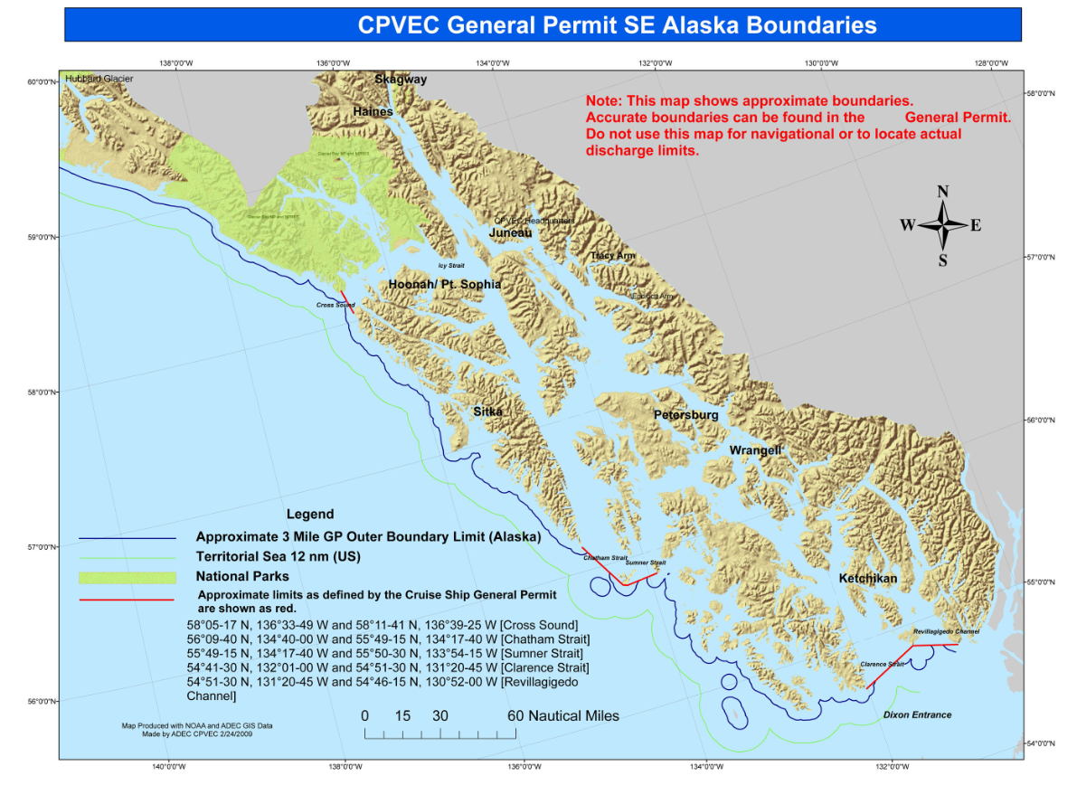
Figure 2- Small Cruise Ship general permit boundaries.

1.6 Project/Task Description and Schedule

1.6.1 Project Description

This QAPP specifies the minimum requirements for sampling and analysis of treated sewage and/or graywater and other wastewaters as defined in AS 46.03.490. All sampling events required by AS 46.03 shall be conducted in accordance with this QAPP. The Cruise Ship Project Manager must provide documentation verifying their compliance with the guidelines in AS 46.03.460-46.03.490, 18 AAC 69, 18 AAC 70, and this plan.

Each vessel discharging wastewater must be sampled at the beginning of the cruise ship season to assess the quality of effluent discharged to Alaskan waters; typically, within 10 days of initial entry into Alaska waters or the start of revenue passenger service in Alaska waters. Vessels are subject to sampling audits at any time while in state waters and ADEC may perform additional sampling and analysis inspections as necessary to implement AS 46.03. Samples that fail to provide valid results for all required parameters will be subject to resampling to the satisfaction of ADEC. Sampling events exceeding the standards below will typically warrant a resample:

  - AS 46.03.463 (b) prohibits discharge of sewage from a commercial passenger vessel into marine waters of the state if the discharge has suspended solids greater than 150 mg/L or a fecal coliform count greater than 200 colonies per 100 ml. (see 33 CFR § 159.319). BMPs allow for Department discretion regarding resampling.
  - Department policy will determine if exceedance of other parameters will require resampling. Total residual chlorine (TRC) is not listed at CFR, but the Department is concerned with high chlorine values in wastewater effluent (i.e., TRC>5 mg/L). MSD units on small vessels often use chlorine is an integral final step. Historically, this parameter has been shown high exceedances from the Alaska Water Quality Standards (WQS) and are indicative of improperly functioning MSD or the overuse of chlorine in the wastewater treatment prior to discharge.

1.6.2 Project Schedule

A Vessel Specific Sampling Plan (VSSP) is approved annually for each vessel operating in AK waters. The VSSP is the primary reference document for sampling required, as sampling may change annually. The 2025-2027 Small Commercial Passenger Vessel Sampling Regime outlines the annual sampling frequency, timeline, and parameters. The sampling regime serves as the basis for each VSSP. DEC reviews and approves VSSP for conformance with current sampling regime. Vessel category determines the group or groups of parameters that must be sampled. Table 1-1 shows the sample frequency outlined in the current sampling regime.

Table 1-1. Sample Frequency depending on Vessel Category
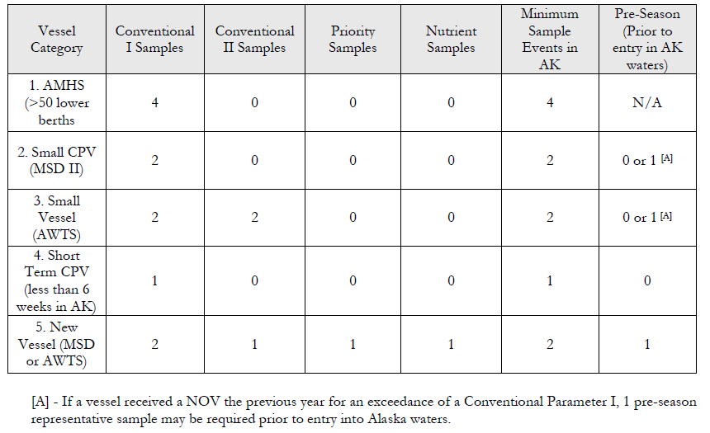
The group of pollutants to be sampled are required under DEC’s Best Management Practice Plan and USCG type approval limits for MSDs (33 CFR 159.53).

Table 1-2 Specific pollutants within each group.
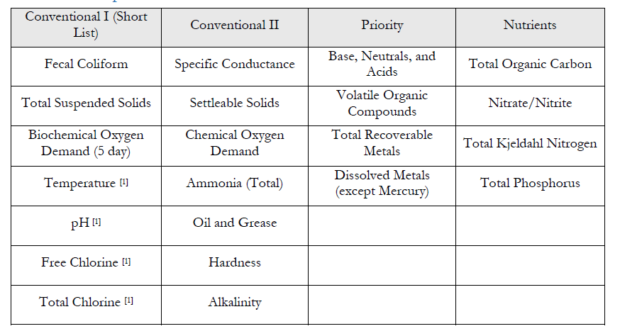

1.7 Quality Objectives and Criteria for Measurement Data

1.7.1 Objectives and Project Decisions

Data Quality Objectives (DQOs) are qualitative and quantitative statements derived from the DQO process that:

- Clarify the monitoring objectives (i.e., determine water/wastewater pollutant concentrations of interest and how these values compare to water quality standards regulatory limits).
- Define the appropriate type of data needed. To accomplish the monitoring objectives, the appropriate type of data needed is defined by the respective WQS. For WQS pollutants, compliance with the WQS is determined by specific measurement requirements. The measurement system is designed to produce water pollutant concentration data that are of the appropriate quantity and quality to assess compliance.

1.7.2 Action Limits/Levels

Table 1-3 outlines the current DEC regulatory compliance limits associated with each method of analysis required for Conventional I pollutants

Table 1-3¹ Analytical parameters include both field and laboratory analyses.
Analytical Parameter¹ | Project Action  Limit/Level  (applicable units)
pH | 6.0-9.0 SU
Free Chlorine | 5.0 mg/L
Total Residual Chlorine | 5.0 mg/L
Total Suspended Solids (TSS) | 150 mg/L
Fecal Coliform (fc) | 200 fc/L

1.7.3 Measurement Performance Criteria/Acceptance Criteria

Measurement Quality Objectives (MQOs) are a subset of DQOs. MQOs are derived from the monitoring project’s DQOs. MQOs are designed to evaluate and control various phases (sampling, preparation, and analysis) of the measurement process to ensure that total measurement uncertainty is within the range prescribed by the project’s DQOs. MQOs define the acceptable quality (data validity) of field and laboratory data for the project. MQOs are defined in terms of the following data quality indicators:
- Detectability
- Precision
- Bias/Accuracy
- Completeness
- Representativeness
- Comparability

Detectability is the ability of the method to reliably measure a pollutant concentration above background. DEC DOW uses two components to define detectability: method detection limit (MDL) and practical quantification limit (PQL) or reporting limit (RL). Individual analyte MDL and PQL limits are listed in Table 1-4.

- The MDL is the minimum value which the instrument can discern above background but no certainty to the accuracy of the measured value. For field measurements the manufacturer’s listed instrument detection limit (IDL) can be used.
- The PQL or RL is the minimum value that can be reported with confidence (usually some multiple of the MDL).

Sample data measured below the MDL is reported as ND or non-detect. Sample data measured ≥ MDL but ≤ PQL or RL is reported as estimated data. Sample data measured above the PQL or RL is reported as reliable data unless otherwise qualified per the specific sample analysis.

TABLE 1-4 Project Measurement Quality Objectives (MQOs)
LAB PARAMETER | Analytical Methods | MDL (mg/L) | PQL (mg/L) | PRECISION (RPD, RSD) | BIAS (% Recovery)
Conventional I and II / Nutrients
Alkalinity | SM 2320 B | 5 | 20 | <20% | 85 - 115 %
Ammonia (Total) | EPA 350.1 Hach 10205 | 0.1 | 0.5 | <20% | 80 - 120 %
Biochemical Oxygen Demand (BOD) | EPA 405.1  SM 5210 | 2.0 | 2.0 | <20% | 70 - 130 %
Chemical Oxygen Demand (COD) | EPA 410.4 Rev 2.0 | 11 | 28 | <20% | 85 - 115 %
Chlorine Residual (Total/Free) | SM 4500-Cl (G) | 0.05 | 0.1 | <20% | N/A
E. coli | SM 9223B | 1.0 | 1.0 | no precision criteria | N/A
Fecal Coliforms (FC) | SM 9222 D | 1.0 FC/100 ml | 2.0 FC/100 ml | no precision criteria | N/A
Hardness | SM 2340 B | 5 | 20 | <20% | 85 - 115 %
Nitrate | EPA 300.0 | 0.1 | 1 | <20% | 85 - 115 %
Nitrate/Nitrite (NO2/NO3) | EPA 350.1 EPA 300.0 | 0.1 | 1 | <20% | 85 - 115 %
Oil and Grease | EPA 1664B | 1.4 | 5.0 | <20% | 60-150%
pH | SM 4500  EPA 150.1 | 0.1 standard units | 0.1 standard units | <20% | N/A
Settleable Solids | SM 2540 F | 0.1 ml/L | 0.1 ml/L | <20% | N/A
Specific Conductance | SM 2510 B | 2 µmHos/ cm | 5 µmHos/cm | <20% | 85 - 115 %
Total Kjeldahl Nitrogen (TKN) | EPA 351.2 Rev 2.0  Hach 10242* | 3 | 10 | <20% | 85 - 115 %
Total Organic Carbon (TOC) | SM 5310C | 0.5 | 1 | <20% | 85 - 115 %
Total Phosphorus | EPA 365.1 Rev 2.0 | 0.3 | 0.5 | <20% | 85 - 115 %
Total Suspended Solids (TSS) | EPA 160.2  SM 2540D | 1.0 | 4.0 | <20% | 85 - 115 %
*Hach Method 10242 was recently approved in the 2021 CLIA QAPP, this method has not been approved for small vessel sampling if high conductivity or high chlorine levels are expected.

LAB PARAMETER | Method | MDL (ug/L) | PQL (ug/L) | PRECISION (RPD) | BIAS (% Recovery)
Priority Pollutants
Total Recoverable Metals
Antimony | EPA 200.8 R  Rev 5.4 | 1 | 5.0 | <20% | 85 - 115 %
Arsenic | EPA 200.8 R  Rev 5.4 | 1 | 5.0 | <20% | 85 - 115 %
Beryllium | EPA 200.8 R  Rev 5.4 | 1 | 5.0 | <20% | 85 - 115 %
Cadmium | EPA 200.8 R  Rev 5.4 | 1 | 5.0 | <20% | 85 - 115 %
Chromium | EPA 200.8 R  Rev 5.4 | 1 | 5.0 | <20% | 85 - 115 %
Copper | EPA 200.8 R  Rev 5.4 | 1 | 3.0 | <20% | 85 - 115 %
Lead | EPA 200.8 R  Rev 5.4 | 1 | 5.0 | <20% | 85 - 115 %
Nickel | EPA 200.8 R  Rev 5.4 | 1 | 5.0 | <20% | 85 - 115 %
Selenium | EPA 200.8 R  Rev 5.4 | 1 | 5.0 | <20% | 85 - 115 %
Silver | EPA 200.8 R  Rev 5.4 | 0.5 | 1.0 | <20% | 85 - 115 %
Thallium | EPA 200.8 R  Rev 5.4 | 1 | 5.0 | <20% | 85 - 115 %
Zinc | EPA 200.8 R  Rev 5.4 | 3 | 10 | <20% | 85 - 115 %
Mercury (Total) | EPA 245.1 Rev 3.0 | 0.1 | 2.0 | <20% | 85 - 115 %
Dissolved Metals
Antimony | EPA 200.8 Rev 5.4 | 1 | 5.0 | <20% | 85 - 115 %
Arsenic | EPA 200.8 Rev 5.4 | 1 | 5.0 | <20% | 85 - 115 %
Beryllium | EPA 200.8 Rev 5.4 | 1 | 5.0 | <20% | 85 - 115 %
Cadmium | EPA 200.8 Rev 5.4 | 1 | 5.0 | <20% | 85 - 115 %
Chromium | EPA 200.8 Rev 5.4 | 1 | 5.0 | <20% | 85 - 115 %
Copper | EPA 200.8 Rev 5.4 | 1 | 3.0 | <20% | 85 - 115 %
Lead | EPA 200.8 Rev 5.4 | 1 | 5.0 | <20% | 85 - 115 %
Nickel | EPA 200.8 Rev 5.4 | 1 | 5.0 | <20% | 85 - 115 %
Selenium | EPA 200.8 Rev 5.4 | 1 | 5.0 | <20% | 85 - 115 %
Silver | EPA 200.8 Rev 5.4 | 0.5 | 1.0 | <20% | 85 - 115 %
Thallium | EPA 200.8 Rev 5.4 | 1 | 5.0 | <20% | 85 - 115 %
Zinc | EPA 200.8 Rev 5.4 | 3 | 10 | <20% | 85 - 115 %

LAB PARAMETER | Method | MDL (ug/L) | PQL (ug/L) | PRECISION (RPD) |  | BIAS (% Recovery)
Volatile Organic Compounds
1,1,1-Trichloroethane | EPA 624.1 | 3.0 | 10 |  | <20% | 52-162%
1,1,2,2-Tetrachloroethane | EPA 624.1 | 3.0 | 10 |  | <20% | 46-157%
1,1,2-Trichloroethane | EPA 624.1 | 3.0 | 10 |  | <20% | 52-150%
1,1-Dichloroethane | EPA 624.1 | 3.0 | 10 |  | <20% | 59-155%
1,1-Dichloroethene | EPA 624.1 | 3.0 | 10 |  | <20% | 5-234%
1,1-Dichloropropene | EPA 624.1 | 3.0 | 10 |  | <20% | 75-125%
1,2-Dichloroethane | EPA 624.1 | 3.0 | 10 |  | <20% | 49-155%
1,2,3-Trichlorobenzene | EPA 624.1 | 3.0 | 10 |  | <20% | 75-125%
1,2,3-Trichloropropane | EPA 624.1 | 3.0 | 10 |  | <20% | 80-120%
1,2,4-Trichlorobenzene | EPA 624.1 | 3.0 | 10 |  | <20% | 75-125%
1,2,4-Trimethylbenzene | EPA 624.1 | 3.0 | 10 |  | <20% | 75-125%
1,2-Dibromo-3-Chloropropane | EPA 624.1 | 3.0 | 10 |  | <20% | 70-130%
1,2-Dichlorobenzene | EPA 624.1 | 3.0 | 10 |  | <20% | 18-190%
1,2-Dichloropropane | EPA 624.1 | 3.0 | 10 |  | <20% | 5-210%
1,3,5-Trimethylbenzene | EPA 624.1 | 3.0 | 10 |  | <20% | 70-130%
1,3-Dichlorobenzene | EPA 624.1 | 3.0 | 10 |  | <20% | 59-156%
1,3-Dichloropropane | EPA 624.1 | 3.0 | 10 |  | <20% | 75-130%
1,4-Dichlorobenzene | EPA 624.1 | 3.0 | 10 |  | <20% | 18-190%
2,2-Dichloropropane | EPA 624.1 | 3.0 | 10 |  | <20% | 60-130%
2-Butanone | EPA 624.1 | 10 | 50 |  | <20% | 60-140%
2-Chloroethyl Vinyl Ether | EPA 624.1 | 3.0 | 10 |  | <20% | 10-305%
2-Chlorotoluene | EPA 624.1 | 3.0 | 10 |  | <20% | 75-135%
2-Hexanone | EPA 624.1 | 3.0 | 10 |  | <20% | 60-140%
4-Chlorotoluene | EPA 624.1 | 3.0 | 10 |  | <20% | 75-130%
4-Isopropyltoluene | EPA 624.1 | 3.0 | 10 |  | <20% | 75-125%
4-Methyl-2-Pentanone | EPA 624.1 | 3.0 | 10 |  | <20% | 60-140%
Acetone | EPA 624.1 | 10 | 50 |  | <20% | 40-160%
Acrolein | EPA 624.1 | 50 | 100 |  | <20% | 40-160%
Acrylonitrile | EPA 624.1 | 50 | 100 |  | <20% | 65-130%
Benzene | EPA 624.1 | 3.0 | 10 |  | <20% | 37-151%
Bromobenzene | EPA 624.1 | 3.0 | 10 |  | <20% | 75-130%
Bromochloromethane | EPA 624.1 | 3.0 | 10 |  | <20% | 35-155%
Bromodichloromethane | EPA 624.1 | 3.0 | 10 |  | <20% | 80-130%
Bromoform | EPA 624.1 | 3.0 | 10 |  | <20% | 45-169%
Bromomethane | EPA 624.1 | 3.0 | 10 |  | <20% | 10-242%
Carbon Disulfide | EPA 624.1 | 3.0 | 10 |  | <30% | 29.3-150%
Carbon Tetrachloride | EPA 624.1 | 3.0 | 10 |  | <30% | 70-30%
Chlorobenzene | EPA 624.1 | 3.0 | 10 |  | <30% | 65-135%
Chloroethane | EPA 624.1 | 3.0 | 10 |  | <30% | 40-160%
Chloroform | EPA 624.1 | 3.0 | 10 |  | <30% | 70-135%
Chloromethane | EPA 624.1 | 3.0 | 10 |  | <30% | 0-205%
Cis-1,2-Dichloroethene | EPA 624.1 | 3.0 | 10 |  | <30% | 82-122%
Cis-1,3-Dichloropropene | EPA 624.1 | 3.0 | 10 |  | <30% | 25-175%
Dibromochloromethane | EPA 624.1 | 3.0 | 10 |  | <30% | 70-135%
Dibromomethane | EPA 624.1 | 3.0 | 10 |  | <30% | 73.2-113%
Dichlorodifluoromethane | EPA 624.1 | 3.0 | 10 |  | <30% | 10-168%
Ethylbenzene | EPA 624.1 | 3.0 | 10 |  | <30% | 60-140%
Hexachlorobutadiene | EPA 624.1 | 3.0 | 10 |  | <30% | 77.8-144%
Iodomethane | EPA 624.1 | 3.0 | 10 |  | <30% | 50-150%
Isopropylbenzene | EPA 624.1 | 3.0 | 10 |  | <30% | 87.4-124%
m&p Xylenes | EPA 624.1 | 3.0 | 10 |  | <30% | 88.9-120%
Methylene Chloride | EPA 624.1 | 3.0 | 10 |  | <30% | 60-140%
n-Butylbenzene | EPA 624.1 | 3.0 | 10 |  | <30% | 85.7-160%
n-Propylbenzene | EPA 624.1 | 3.0 | 10 |  | <30% | 80.6-133%
O-Xylene | EPA 624.1 | 3.0 | 10 |  | <30% | 87-117%
sec-Butylbenzene | EPA 624.1 | 3.0 | 10 |  | <30% | 90-144%
Styrene | EPA 624.1 | 3.0 | 10 |  | <30% | 74.1-116%
tert-Butyl Methyl Ether | EPA 624.1 | 3.0 | 10 |  | <30% | 64.5-113%
tert-Butylbenzene | EPA 624.1 | 3.0 | 10 |  | <30% | 86.1-132%
Tetrachloroethene | EPA 624.1 | 3.0 | 10 |  | <30% | 70-130%
Toluene | EPA 624.1 | 3.0 | 10 |  | <30% | 70-130%
Trans 1,2-Dichloroethene | EPA 624.1 | 3.0 | 10 |  | <30% | 70-130%
trans-1,3-Dichloropropene | EPA 624.1 | 3.0 | 10 |  | <30% | 50-150%
trans-1,4-Dichloro-2 Butene | EPA 624.1 | 3.0 | 10 |  | <30% | 50-150%
Trichloroethene | EPA 624.1 | 3.0 | 10 |  | <30% | 65-135%
Trichlorofluoromethane | EPA 624.1 | 3.0 | 10 |  | <30% | 50-150%
1,1,2-Trichloro-1,2,2-Trifluoroethane | EPA 624.1 | 3.0 | 10 |  | <30% | 50-150%
Vinyl Acetate | EPA 624.1 | 3.0 | 10 |  | <30% | 55-126%
Vinyl Chloride | EPA 624.1 | 3.0 | 10 |  | <30% | 5-195%

LAB PARAMETER | Method | MDL (ug/L) | PQL (ug/L) | PRECISION (RPD) | BIAS (% Recovery)
Base/Neutral & Acids
1,2-Diphenylhydrazine | EPA 625.1 | 3.0 | 10 | <40% | 60-140%
2,2’-Oxybis (1-chloropropane) | EPA 625.1 | 3.0 | 10 | <40% | 36-166%
2,4,5-Trichlorophenol | EPA 625.1 | 3.0 | 10 | <40% | 60-140%
2,4,6-Trichlorophenol | EPA 625.1 | 3.0 | 10 | <40% | 37-144%
2,4-Dichlorophenol | EPA 625.1 | 3.0 | 10 | <40% | 55-130%
2,4-Dimethylphenol | EPA 625.1 | 10 | 30 | <40% | 15-130%
2,4-Dinitrophenol | EPA 625.1 | 10 | 30 | <40% | 25-191%
2,4-Dinitrotoluene | EPA 625.1 | 3.0 | 10 | <40% | 39-139%
2,6-Dinitrotoluene | EPA 625.1 | 3.0 | 10 | <40% | 50-158%
2-Chloronapthalene | EPA 625.1 | 3.0 | 10 | <40% | 30-170%
2-Chlorophenol | EPA 625.1 | 3.0 | 10 | <40% | 23-134%
2-Methylnaphthalene | EPA 625.1 | 3.0 | 10 | <40% | 40-140%
2-Methylphenol | EPA 625.1 | 3.0 | 10 | <40% | 50-115%
2-Nitroaniline | EPA 625.1 | 3.0 | 10 | <40% | 50-115%
2-Nitrophenol | EPA 625.1 | 3.0 | 10 | <40% | 50-115%
3,3’-Dichlorobenzidine | EPA 625.1 | 10 | 50 | <40% | 30-170%
3/4-Methylphenol | EPA 625.1 | 3.0 | 10 | <40% | 30-125%
3-Nitroaniline | EPA 625.1 | 30 | 55 | <40% | 30-170%
4,6-Dinitro-2-methylphenol | EPA 625.1 | 10 | 30 | <40% | 25-181%
4-Bromophenyl Phenyl ether | EPA 625.1 | 3.0 | 10 | <40% | 50-140%
4-chloro-3-methylphenol | EPA 625.1 | 3.0 | 10 | <40% | 22-147%
4-Chloroaniline | EPA 625.1 | 3.0 | 10 | <40% | 30-170%
4-Chlorophenylmethylsulfone | EPA 625.1 | 3.0 | 10 | <40% | 30-170%
4-Chlorophenyl Phenyl ether | EPA 625.1 | 3.0 | 10 | <40% | 50-150%
4-Nitroaniline | EPA 625.1 | 30 | 55 | <40% | 40-110%
4-Nitrophenol | EPA 625.1 | 10 | 30 | <40% | 25-132%
Acenaphthene | EPA 625.1 | 3.0 | 10 | <40% | 40-145%
Acenaphthylene | EPA 625.1 | 3.0 | 10 | <40% | 33-145%
Anthracene | EPA 625.1 | 3.0 | 10 | <40% | 27-133%
Benzidine | EPA 625.1 | 30 | 55 | <40% | 30-170%
Benzo (A) Anthracene | EPA 625.1 | 3.0 | 10 | <40% | 33-143%
Benzo (A) Pyrene | EPA 625.1 | 3.0 | 10 | <40% | 17-163%
Benzo (B) Fluoranthene | EPA 625.1 | 3.0 | 10 | <40% | 24-159%
Benzo (g,h,i) Perylene | EPA 625.1 | 3.0 | 10 | <40% | 5-219%
Benzo (K) Fluoranthene | EPA 625.1 | 3.0 | 10 | <40% | 11-162%
Benzoic Acid | EPA 625.1 | 3.0 | 10 | <40% | 5-110%
Benzyl Alcohol | EPA 625.1 | 3.0 | 10 | <40% | 24-149%
Bis (2-Chloroethoxy) methane | EPA 625.1 | 3.0 | 10 | <40% | 33-184%
Bis (2-chloroethyl) ether | EPA 625.1 | 3.0 | 10 | <40% | 12-158%
Bis (2-Ethylhexyl) Phthalate |  | 3.0 | 10 | <40% | 8-158%
Butyl Benzyl Phthalate |  | 3.0 | 10 | <40% | 5-152%
Chrysene |  | 3.0 | 10 | <40% | 17-168%
Dibenzo (a,h) Anthracene |  | 3.0 | 10 | <40% | 5-227%
Dibenzofuran |  | 3.0 | 10 | <40% | 50-130%
Diethyl Phthalate |  | 3.0 | 10 | <40% | 5-114%
Dimethyl Phthalate |  | 3.0 | 10 | <40% | 5-112%
Di-N-Butyl Phthalate |  | 3.0 | 10 | <40% | 60-160%
Di-N-Octyl Phthalate |  | 3.0 | 10 | <40% | 5-146%
Fluoranthene |  | 3.0 | 10 | <40% | 26-137%
Fluorene |  | 3.0 | 10 | <40% | 55-130%
Hexachlorobenzene |  | 3.0 | 10 | <40% | 5-152%
Hexachlorocyclopentadiene |  | 3.0 | 10 | <40% | 30-170%
Hexachloroethane |  | 3.0 | 10 | <40% | 40-140%
Indeno (1,2,3-CD) Pyrene |  | 3.0 | 10 | <40% | 5-171%
Isophorone |  | 3.0 | 10 | <40% | 21-196%
Napthalene |  | 3.0 | 10 | <40% | 21-133%
Nitrobenzene |  | 3.0 | 10 | <40% | 35-180%
N-Nitrosodimethylamine |  | 3.0 | 10 | <40% | 30-170%
N-Nitrosodi-N-Propylamine |  | 3.0 | 10 | <40% | 5-230%
N-Nitrosodiphenylamine |  | 3.0 | 10 | <40% | 60-140%
Pentachlorophenol |  | 10 | 30 | <40% | 25-176%
Phenanthrene |  | 3.0 | 10 | <40% | 50-140%
Phenol |  | 3.0 | 10 | <40% | 5-112%
Pyrene |  | 3.0 | 10 | <40% | 45-135%

Precision is the degree of agreement among repeated measurements of the same parameter and provides information about the consistency of methods. Precision is expressed in terms of the relative percent difference between two measurements (A and B).

For field measurements, precision is assessed by measuring replicate (paired) samples at the same locations and as soon as possible to limit temporal variance in sample results. Field and laboratory precision are measured by collecting blind (to the laboratory) field replicate or duplicate samples. For paired and small data sets project precision is calculated using the following formula:
$$RPD=\frac{\left(A-B\right)}{\left(\left(A+B\right)/2\right)}×100$$

RPD = relative percent difference
A = primary sample
B = replicate field sample or laboratory duplicate sample

Bias (Accuracy) is a measure of confidence that describes how close a measurement is to its “true” value. Acceptance limits for Bias for each analyte are listed in Table 1-4. Methods to determine and assess accuracy of field and laboratory measurements include, instrument calibrations, various types of QC checks (e.g., sample split measurements, sample spike recoveries, matrix spike duplicates, continuing calibration verification checks, internal standards, sample blank measurements (field and lab blanks), external standards, performance audit samples (DMRQA, blind Water Supply or Water Pollution PE samples from A2LA certified, etc. Bias/Accuracy is usually assessed using the following formula:

Completeness is a measure of the percentage of valid samples collected and analyzed to yield sufficient information to make informed decisions with statistical confidence. The completeness criterion for this project is 80 percent of the compiled analytical data per each analytical parameter for each vessel participating in the program. Because of the variety of vessels and discharges sampled, and the possibility for weather or other shipping-related delays resulting in missed holding times, a completeness criterion of less than 100% is to be expected.
Project completeness is determined for each pollutant parameter using the following formula:

T – (I+NC) x (100%) = Completeness
T

T = Total number of expected sample measurements
I = Number of invalid sample measurements
NC = Number of sample measurements not produced (e.g., spilled sample, etc.).

Representativeness is a measure of how well the sample reflects the typical wastewater effluent. Sample representativeness will be established by collecting cruise ship graywater, blackwater, and other wastewater discharge samples following vessel specific sampling plans (VSSP). The owner and operator are responsible for developing and submitting VSSPs to both agencies for each vessel participating in the program.

The treatment system effluent will be considered representative for the two samples only if the vessel normally discharges continuously. The VSSP is designed to ensure that consistent sampling methods are followed and that samples are collected from appropriate and representative locations at appropriate times.

Vessel operation that differs from the approved VSSP may result in rejection of samples by the Department.

Comparability is a measure that shows how data can be compared to other data collected by using standardized methods of sampling and analysis. Comparability is shown by referencing the appropriate measurement method approved by as specified in federal and/or state regulatory and guidance documents/methods for the parameter/s to be sampled and measured (e.g., ASTM, Standard Methods, Alaska Water Quality Standards, EPA Guidelines Establishing Test Procedures for the Analysis of Pollutants Under the Clean Water Act; National Primary Drinking Water Regulations; and National Secondary Drinking Water Regulations; Analysis and Sampling Procedures, etc.). As with representativeness and completeness, comparability is determined during project development and must be specified in the QAPP.

For each parameter to be sampled/measured, list the measurement method to be used and the MQOs to meet the overall data quality objectives. This applies to both direct field measurements (e.g., field pH meters, DO meters, etc.) as well as samples collected for subsequent laboratory analyses.

Because of the different source types found on different vessels (e.g., a holding tank on some ships may contain both blackwater and graywater, while on others it may only contain graywater), careful definition of discharge types will be made in the VSSP. It is essential that these definitions be carried through to the end data user, as these differences could erroneously bias data interpretation.

The sampling team must make full use of ship records and logs, especially the Graywater and Sewage Discharge Record Book which includes the latitude and longitude at the beginning and end of discharge, identifying tanks, estimating volumes and calculating discharge rates (if any) at the time the sample is drawn. If the vessel is discharging continuously (not just certified but is in practice) then the sampler does not need to record latitude and longitude at the beginning and end of discharge, identifying tanks, estimating volumes of those tanks. The sampler needs to identify which treatment unit is discharging and the discharge rate. The vessel speed and longitude/latitude must be obtained by the sampler if the sample is taken while the vessel is discharging underway. Information added to the VSSP or changes to the VSSP during the sampling event must be recorded on the VSSP, Chain of Custody (COC), or in the field notes and must accompany the samples to the lab and be provided to the project data recipients as part of the complete unannounced sampling report.

1.8 Special Training Requirements/Certification

The Cruise Ship Project Manager shall ensure that sampling is conducted by a qualified, approved person as required by 18 AAC 69.090. The owner/operator must submit information describing the qualifications of field personnel to be approved no later than 21 days before sampling is conducted. To determine whether a person is qualified, the department will consider whether the person is:

1) trained in sampling methodology, sample handling, chain of custody, field measurements, and quality assurance procedures; and

2) is familiar with this QAPP and VSSP for the vessels sampled.

Training records should be available upon request and operators. Operators should train staff in updated methods or procedures to ensure quality of sampling. Additionally, samplers will receive appropriate training relating to shipboard safety procedures.

Due to the short holding time for fecal coliform samples collected, only DEC Drinking Water Certified laboratories will be used. Additional samples sent to a lab for analysis must be analyzed by a laboratory with current certification under one of the following laboratory certification programs:

- ADEC-Drinking Water Certified Laboratory for Chemistries [1]
https://dec.alaska.gov/eh/lab/chem-lab-cert-status.aspx

- ADEC-Drinking Water Certified Laboratory for Microbiological / Fecal Coliforms [1, 2]
https://dec.alaska.gov/eh/lab/micro-lab-cert-status/

- Washington State Department of Ecology (WA DOE) Certified Water/Wastewater Laboratory for Chemistries
https://ecology.wa.gov/Regulations-Permits/Permits-certifications/Laboratory-Accreditation

- NELAC Certified Water/Wastewater Laboratory
https://lams.nelac-institute.org/

[1] ADEC does not certify laboratories for water/wastewater analyses. Although water/wastewater methodologies may differ somewhat from drinking water analytical methods, an ADEC drinking water-approved laboratory lends credibility to a laboratory’s quality assurance and quality control processes.
[2] For microbiological analyses conducted in state waters, only in-state labs with a current ADEC drinking water certification may be used. Due to the short sample holding time requirements.

1.9 Documents and Records

1.9.1 QA Project Plan Distribution

The Cruise Ship Project Manager is responsible for QAPP revisions/updates. The Cruise Ship Project Manager will provide drafted QAPP versions to ADEC program manager, ADEC QA Officer, and Project QA Manager for review(s) and finalization. If updates are required, tracked changes will be used by all parties for full transparency. Following acceptance of revisions, signatures from all representatives are collected. Due to the physical distance between potential signatories of this document, electronic signatures will be acceptable. Once all signatures have been obtained, the final document is distributed to all parties in PDF format by the ADEC Program Manager.

The following document control information will appear in the upper right corner of each page of the Quality Assurance Project Plan (QAPP).

Small CPV Alaska QAPP
Revision Number:______
Revision Date: ________
Page _____ of ______

1.9.2 Field Documentation and Records

A unique reference number will be assigned to each sampling event. Field documentation will be on pre-printed forms for each event, and will include COC(s), field notes, and a sampling checklist. Due to the physical distance between ships and concurrent timing of many sampling events, it is impractical for field notes to be contained within bound logbooks. A photograph of the sampling point will also be included as a part of the field record. Field documents will be kept electronically and physically (if applicable) at the office of the Sampling Team Leader.

The unique reference number, ship name, sample location ID, date, and time of sample will be included on sample bottles, field documents, and included in the photograph of the sampling port.

The sample location ID should clearly state where the sample was taken and align with the VSSP. For example, a sample from the overboard discharge from the M/V Hypothetica will be identified as “OB Discharge Port A,” if the VSSP identifies “Port A” as the representative Alaska sampling point. All samplers will use the same sample location ID system.
Entries will be made legibly with pencil or blue/black ink. Data corrections shall be done by drawing a single line through the incorrect data and initialing/dating the new data. Under no circumstances should the incorrect material be erased, made illegible or obscured so that it cannot be read. On-board staff will witness the sampling and will initial the field notes.
Field notes for each sample should include:
- Vessel name (e.g., M/V Hypothetica),
- Sample date and times (start/stop)
- Location/Speed: Latitude/longitude (or Port/City name) and speed during sample event.
- Sampling personnel,
- Shipboard assistants,
- Waste type: blackwater, graywater, or mixed,
- Type of sample: Composite or Grab,
- Samples collected: Conventional I/ Conventional II/Priority/Nutrients
- Discharge rate during sample event & holding tank volumes (underway only)
- Field measurements: pH, free chlorine, total chlorine, and temperature
- Calibration dates of instruments used (Unique names of devices if applicable)
- Signature/initials by vessel crew indicating that the sample port is correct,
- Deviations from VSSP and/or QAPP,
- Comments: Note any unusual conditions and explanation of data anomalies,
- Copy of Discharge Logs (printout/photo) showing wastewater flow rate.
- Photo of sample port.

Chain of Custody Forms and Custody Seals

The original chain of custody form(s) will accompany the sample to the laboratory. When portions of the sample are sent to another laboratory (e.g., for many of the priority pollutants), a copy of the chain of custody will be made and this will accompany the samples. At each transfer of the sample, the transfer will be indicated on the chain of custody form. The sampler listed on the chain of custody should have custody of the sample until the COC is relinquished by that person and received by the next party signed on the COC. Custody of the sample means either in the sampler’s physical possession, within their view, or locked/secured with restricted access. If the sample is unable to maintain this (such as flying with samples as checked baggage), a custody seal will be applied to the sampling cooler for at least that duration.

A scanned PDF of the original chain of custody form(s) will be included with the final data package including the COC(s) transferring samples to other labs.

Photograph

A photograph of the sample collection point will be taken during every sampling event. The photo will include the ship name, sampling port ID, date, and time. The photograph will also include identifying marks or signage at the sampling point if possible.

1.9.3 Laboratory Documentation and Records

The Project Manager will review laboratory results and reports. The Project Manager will ensure that analytical laboratories utilized provide a full report in a level III electronic format describing the results of analysis for each sample submitted.

All data packages will be submitted electronically by the vessel operator or their designee into Environmental Data Management System (EDMS). The owner/operator (Permittee) is responsible for meeting submittal deadlines.

1.9.3.1 Final Reporting Deadlines

Complete data packages will be delivered to ADEC within 21 days of completion of laboratory analyses. All permit/regulatory exceedances must be reported to ADEC within 24 hours of receiving analytical data that has passed final laboratory QA review. If data are/will be delayed due to circumstances outside of the laboratory’s control, the ADEC Project Manager will notify the regulatory agencies and Project QA Officer (e.g., unexpected/unplanned instrument maintenance).

2.0 DATA GENERATION AND ACQUISITION

2.1 Sampling Design

The VSSP for each ship will be developed by the project manager and submitted to the sampling team 21 days prior to sampling. This plan needs to be approved by the ADEC. The plan will include elements listed in 18 AAC 69.030, and as a minimum, the following:
- Vessel name.
- Passenger and crew capacity of ship.
- Daily water use per individual.
- Locations and capacities for treated sewage, graywater, and other wastewater tanks.
- Type of wastewater treatment systems.
- Each discharge pump type and rate
- Vessel schematic of discharge ports and corresponding sampling ports.
- Description of discharges, including anticipated flow rates and tank volumes.
- Table containing type of discharge, type of sample (grab or composite), parameters (conventional or priority pollutants), location on the vessel where each sample is to be collected, and special circumstances.
- A narrative description of the time at which each sample is to be taken based upon circumstances that will yield a sample most likely to be representative of the average discharge that passes through the location where the sample is taken
- A description of the standards the owner or operator will use to determine a deviation from the plan
- Equipment required.
- Site map with locations
- Sampling design, Table 2-1
- Summary of field and QC samples to be collected, Table 2-2

Each VSSP will be dated, and a copy will be provided to ADEC. The ADEC must approve the VSSP prior to sampling. After the first sampling event on a vessel, the VSSP may be updated. If it is updated, copies of the updated sampling plan must be submitted to and approved by ADEC before the second round of sampling occurs.
¹ Analytical parameters include all planned field measurements and laboratory analyses.

Table 2-1. Sampling Design

Sampling Location/ID  Number | Matrix/  Media | Depth  (Appropriate  Units) | Analytical  Parameter¹
"MSD Overboard (OB) discharge port ___" (numerical or alphabetical ID of port is specific to each vessel and outlined in the VSSP) | MSD Effluent (H2O) Graywater, or Blackwater/ mixed | N/A | All analytical parameters will be collected from this sampling location.

Table 2-2. Summary of Field and QC Samples To Be Collected
Matrix/ Media | Analytical Parameter¹ | No. of Sampling Locations | No. of field duplicates | Organic Analyses² No. of: |  | Inorganic Analyses² No. of: |  | No. of trip blanks (for VOCs only) | No. of PE Samples³
 |  |  |  | MS | MSD | Dup | MS | No. of trip blanks (for VOCs only) | No. of PE Samples³
FIELD MEASUREMENTS:
MSD Effluent (H₂O) Graywater, or Blackwater/mixed | pH | refer to VSSP | 10%⁴ | N/A | N/A | N/A | N/A | N/A | 1/year
MSD Effluent (H₂O) Graywater, or Blackwater/mixed | Chlorine, residual (total) | refer to VSSP | 10%⁴ | N/A | N/A | N/A | N/A | N/A | 1/year
MSD Effluent (H₂O) Graywater, or Blackwater/mixed | Chlorine, free | refer to VSSP | 10%⁴ | N/A | N/A | N/A | N/A | N/A | 1/year
MSD Effluent (H₂O) Graywater, or Blackwater/mixed | Large temperature blank | refer to VSSP | 10%⁴ | N/A | N/A | N/A | N/A | N/A | N/A
MSD Effluent (H₂O) Graywater, or Blackwater/mixed | Small temperature blank | refer to VSSP | 10%⁴ | N/A | N/A | N/A | N/A | N/A | N/A
LABORATORY ANALYSES:
MSD Effluent (H2O) Graywater, or Blackwater/mixed | Total Suspended Solids | refer to VSSP | 10%⁴ | N/A | N/A | N/A | N/A | N/A | 1/year
MSD Effluent (H2O) Graywater, or Blackwater/mixed | Settleable Solids | refer to VSSP | 10%⁴ | N/A | N/A | N/A | N/A | N/A | 1/year
MSD Effluent (H2O) Graywater, or Blackwater/mixed | Biochemical Oxygen Demand (BOD) | refer to VSSP | 10%⁴ | N/A | N/A | N/A | N/A | N/A | 1/year
MSD Effluent (H2O) Graywater, or Blackwater/mixed | Ammonia – Total | refer to VSSP | 10%⁴ | NAS | NAS | N/A | N/A | N/A | 1/year
MSD Effluent (H2O) Graywater, or Blackwater/mixed | Chemical Oxygen Demand (COD) | refer to VSSP | 10%⁴ | NAS | NAS | N/A | N/A | N/A | 1/year
MSD Effluent (H2O) Graywater, or Blackwater/mixed | Specific Conductance | refer to VSSP | 10%⁴ | N/A | N/A | N/A | N/A | N/A | 1/year
MSD Effluent (H2O) Graywater, or Blackwater/mixed | Fecal coliforms | refer to VSSP | 10%⁴ | N/A | N/A | N/A | N/A | N/A | 1/year
MSD Effluent (H2O) Graywater, or Blackwater/mixed | Alkalinity | refer to VSSP | 10%⁴ | N/A | N/A | N/A | N/A | N/A | 1/year
MSD Effluent (H2O) Graywater, or Blackwater/mixed | Oil and Grease | refer to VSSP | 10%⁴ | NAS | NAS | N/A | N/A | N/A | 1/year
MSD Effluent (H2O) Graywater, or Blackwater/mixed | Total Organic Carbon (TOC) | refer to VSSP | 10%⁴ | NAS | NAS | N/A | N/A | N/A | 1/year
MSD Effluent (H2O) Graywater, or Blackwater/mixed | Total Kjeldahl Nitrogen | refer to VSSP | 10%⁴ | NAS | NAS | N/A | N/A | N/A | 1/year
MSD Effluent (H2O) Graywater, or Blackwater/mixed | Total Phosphorus | refer to VSSP | 10%⁴ | NAS | NAS | N/A | N/A | N/A | 1/year
MSD Effluent (H2O) Graywater, or Blackwater/mixed | Hardness | refer to VSSP | 10%⁴ | N/A | N/A | N/A | N/A | N/A | 1/year
MSD Effluent (H2O) Graywater, or Blackwater/mixed | Nitrate/Nitrite | refer to VSSP | 10%⁴ | NAS | NAS | N/A | N/A | N/A | 1/year
MSD Effluent (H2O) Graywater, or Blackwater/mixed | BNA | refer to VSSP | 10%⁴ | N/A | N/A | N/A | N/A | N/A | 1/year
MSD Effluent (H2O) Graywater, or Blackwater/mixed | VOCs (Acrolein, Acrylonitrile, 2-chloroethyl vinyl ether) | refer to VSSP | 10%⁴ | NAS | NAS | N/A | N/A | 1/sample (unpres.) | 1/year
MSD Effluent (H2O) Graywater, or Blackwater/mixed | VOCs (all other compounds) | refer to VSSP | 10%⁴ | NAS | NAS | N/A | N/A | 1/sample (pres. HCl) | 1/year
MSD Effluent (H2O) Graywater, or Blackwater/mixed | Total metals | refer to VSSP | 10%⁴ | N/A | N/A | NAS | NAS | N/A | 1/year
MSD Effluent (H2O) Graywater, or Blackwater/mixed | Dissolved metals | refer to VSSP | 10%⁴ | N/A | N/A | NAS | NAS | N/A | 1/year
¹ Analytical parameters include all laboratory analyses and field measurements.
² Information includes the number of associated analytical QC samples, if collection of additional sample volume and/or bottles is necessary. If the QC samples listed are part of the analysis and don’t require the collection of additional sample volume and/or bottles, NAS (for no additional sample) is included in the column. (Note: MS=matrix spike, MSD=matrix spike duplicate, Dup=laboratory duplicate/replicate.)
³ PE or Performance Evaluations will be completed annually for all parameters noted.
⁴10% refers to percentage of all samples within a sampling season/calendar year

2.2 Sampling Methods

Specific sampling techniques for each vessel will be detailed in the VSSP. The following general guidelines are listed to provide consistency among the vessels utilizing this QAPP.

Samples will reflect a representative discharge of treated blackwater, graywater and other wastewaters into applicable waters of Alaska from an operable marine sanitation device, other treatment system, a holding tank or some combination as specified in the VSSP. In port sampling, in compliance with ADEC sampling events, will be conducted only if the vessel is certified to discharge in port. If samples must be taken while the ship is underway, care will be taken to assure sample representativeness and homogeneity. See VSSP for further details on sampling.

Samplers should wear disposable gloves and safety eyewear, if needed, and observe precautions while collecting samples, remaining aware of the potential chemical and biological hazards present. The Project Sampling Staff collecting samples will take care not to touch the insides of bottles or lids/caps during sampling.

Prior to collecting the sample, the sampler will flush the sample valve at least 10 times the volume of the discharge line from the sampling port prior to collection. Samples are collected in certified clean laboratory bottles (single use). All samples are collected directly from the sampling port outlined in the VSSP, with the exception of blind duplicate sampling. For these duplicate events, the Project QA manager will provide a certified clean cubitainer which will be filled from the sampling port and then dispensed into two separate sets of bottles. This cubitainer is then discarded. All microbiology samples are collected directly from the sampling port.

Samplers will contain all solid and liquid wastes generated during sampling (used gloves, paper towels, chlorine test waste, and overflow from filling of VOC sampling vials) and will dispose of it properly at the conclusion of the sampling event.

2.3 Sample Handling and Custody

Samples will be listed “grab” on the Chain-of- Custody or Transmission Form and in field logbook or field data sheets. All parameters are to be collected as grab samples.

All sampling equipment and sample containers will be cleaned according to the equipment specifications and/or the analytical laboratory. Bottles supplied by a laboratory are pre-cleaned and must never be rinsed and will be filled only once with sample.

For samples requiring cooling, a temperature blank shall accompany each cooler shipment. Care will be taken to avoid spilling any preservative from sample bottles or leakage of acid preservative. Sample bottle lids will be securely fastened and checked when received from the laboratory and resecured after filling.

Samples and sample containers will be maintained in a secure environment, from the time the bottles leave the laboratory until the time the samples are received at the laboratory. The laboratories will maintain custody of bottles and samples using their normal custody procedures.

Blind field duplicates will be identified with discrete sampling labels and recorded as blind field duplicates in the sampler's field notebook.

To maintain the secure environment for samples on board the ship and during transport, samples must be: 1) in the sampler’s possession (line of sight); or 2) in a cooler sealed with signed and dated friable evidence tape on opposing sides of the cooler; or 3) in a locked cooler for which only the sampler has the key. When the cooler is sealed, the method of securing the samples must be such that tampering with samples or bottles is not possible: The cooler must be secured so that the lid cannot be removed without breaking the evidence tape or cutting the lock, so that tampering would be evident.

Transfer of samples will be accomplished using the laboratory’s chain of custody form. When samples are transferred between personnel, such transfer will be indicated on the chain of custody form with signature, date, and time of transfer. The chain of custody will remain with the samples, sealed inside the cooler, until received by the laboratory.

At any time during sample transfer, if custody is broken, a note must be made on the chain of custody form accompanying the sample. Upon receipt at the laboratory, the laboratory sample custodian will make note if a breach of custody has occurred (for example, if a custody seal has broken during transport).

Samples will be held within the respective method specified sample temperature holding requirements (see Table 2-3. Analytical Method, Containers, Preservations, Holding Time Requirements). A temperature blank will accompany all cooler and will be measured at the laboratory upon receipt of the samples to verify the temperature. The temperature of this blank will be recorded on the chain of custody upon receipt of the sample at the lab.

To maintain the temperature, extra blue ice will be kept frozen on-board ship or ship ice will be used. Blue ice or ship ice will be exchanged just before shipment of samples to the lab and may be exchanged more frequently during the sampling trip, as required.

Holding time limitations must be considered when decisions are made regarding sampling and shipping times. Sample holding times are as described in Table 2-3. Planned sample shipping schedules will allow for the meeting of these holding times.

The most critical holding time will be that of fecal coliforms, which is defined by EPA as 6 hours from sample collection to laboratory receipt of sample and an additional time of 2 hours from sample receipt at lab to initiating the sample incubation period. The hold time for fecal coliform samples will be 8 hours from collection to the start of analysis. This mirrors the time frame approved for the CLIA QAPP (used by large commercial passenger vessels), and reflects guidance provided to ADEC by the EPA.

Table 2-3. Analytical Method, Containers, Preservation, and Holding Times Requirements

Matrix/Media: MSD Effluent

Analytical  Parameter¹  and/or  Field Measurements² | Containers (number,  size/volume,  type) | Preservation  Requirements  (chemical,  temperature,  light protection) | Maximum  Holding Times³ | Minimum Representative Volume
FIELD MEASUREMENTS:
pH | P, FP, G | None required | <15 minutes in the field | 25 ml
Temperature | P, FP, G | None required | <15 minutes in field | 1000 ml
Chlorine Free | P, G | None required | < 15 minutes in field | 100 ml
Chlorine Residual (TRC) | P, G | None required | < 15 minutes in field | 100 ml
ANALYTICAL PARAMETERS:
Alkalinity | P, FP, G | Cool, ≤6° C | 14 days | 100 ml
Ammonia – Total | P, FP, G | Cool, ≤6° C, H₂SO₄ to  pH <2 | 28 days | 400 ml
Biochemical Oxygen Demand – 5 day (BOD) | P, FP, G | Cool, ≤6° C | 48 hours | 1000 ml
Chemical Oxygen Demand | P, FP, G | Cool, ≤6° C, H₂SO₄ to pH <2, do not freeze | 28 days | 50 ml
Specific Conductance | P, FP, G | Cool, ≤6° C, do not freeze | 28 days | 100 ml
Fecal Coliforms (FC) | Sterile PA, G | Cool, ≤10° C with no indication of sample freezing 0.0008% Na₂S₂O₃ | 8 hours from sample collection analysis | 100 ml
Hardness | P, FP, G | HN0₃ or H₂SO₄ to pH <2 | 6 months | 100 ml
Nitrate/Nitrite | P, FP, G | Cool, ≤6° C, do not Freeze, H₂SO₄ to pH<2 | 28 days | 100 ml
Oil and Grease | G | Cool, ≤6° C, HCL or H₂SO₄ to pH <2, do not freeze | 28 days | 1000 ml
Total Settleable Solids (TSS) | P, FP, G | Cool, ≤6° C | 7 days
Settleable Solids | P, FP, G | Cool, ≤6° C | 48 hours
Total Kjeldahl Nitrogen (TKN) | P, FP, G | Cool, ≤6° C, H₂SO₄ to pH <2, do not freeze | 28 days | 500 ml
Total Organic Carbon (TOC) | P, FP, G | Cool, ≤6° C, HCL, H₂SO₄ or H₃PO₄ to pH <2, do not freeze | 28 days | 50 ml
Total Phosphorus | P, FP, G | Cool, ≤6° C, H₂SO₄ to  pH <2 | 28 days | 50 ml
Priority Pollutants
BNA | G, FP-lined cap | Cool, ≤6° C, 0.008%, do not freeze, Na₂S₂O₃ if residual chlorine is detected above 0.1 mg/L | 7 days until extraction, 40 days after extraction | 1000 ml
VOCs (except acrolein, acrylonitrile, and 2-chloroethyl vinyl ether) | EPA 624.1 | duplicate 40ml vials, G, FP-lined septum | Cool, ≤6° C, do not freeze, 0.008% Na2S2O3 or ascorbic acid if residual chlorine is detected above 0.1 mg/L, HCl to pH <2, sample filled to zero headspace | 14 days
2-chloroethyl vinyl ether | EPA 624.1 | 40ml vial, G, FP-lined septum | Cool, ≤6° C, do not freeze, 0.008% Na2S2O3 or ascorbic acid if residual chlorine is detected above 0.1 mg/L,sample filled to zero headspace | 7 days
Acrolein and Acrylonitrile | EPA 624.1 |  | Cool, ≤6° C, do not freeze, pres. HCl to pH 4-5, 0.008% Na2S2O3 or ascorbic acid if residual chlorine is detected above 0.1 mg/L,sample filled to zero headspace | 3 days if no acid preservative, 14 days if pH is 4-5
Total Aromatic & Total Aqueous Hydrocarbons | See BNAs and VOCs
Total Mercury (CVAA) | P, FP, G | HNO₃ to pH <2, do not freeze | 28 days | 100 ml
Total Recoverable Metals | P, FP, G | HNO₃ to pH <2, do not freeze | 6 months | 100 ml
Dissolved Metals | P, FP, G | Filtration w/0.45-micron filter within 15 minutes of sample collection, HNO₃ to pH <2, do not freeze | 6 months | 200 ml
P = polyethylene, FP = flouropolymer, G = glass, PA = autoclavable plastic

2.4 Analytical Methods

Laboratories selected by the Project Manager to provide analytical support to the Small Cruise Ship Program for water/wastewater samples collected within Alaska at a minimum must meet the specifications found in section 1.8 Project Description.

Analyses shall be conducted in accordance with EPA-approved analytical procedures and in compliance with 40 CFR Part 136, Guidelines Establishing Test Procedures for Analysis of Pollutants. Reference the Project’s MQO Table 1-4 of this QAPP for list of parameters of concern, approved analytical methods, method-specific detection and reporting limits, accuracy and precision criteria limits applicable to this project. 40 CFR, Part 136.6 lists other regulated pollutant parameters not listed in Table 1-4. Only approved methods for water/wastewater (not drinking water) will be used for the analysis of microbiological, chemical, and physical measurements.

The Project Manager must ensure that any lab performing analytical work on samples collected within Alaska can provide (or has on file with the DEC DOW QA Officer) a current electronic copy of their approved Laboratory Quality Assurance Manual (and respective measurement method SOPs to the ADEC Division of Water QA Officer and DEC Project Manager. These documents must specify calibration and quality control (QC) criteria, practices and procedures for each method employed that are essential in the review, validation, and verification and reporting of sample result data.

2.4.1 Field Measurements Methods

Temperature, pH, and chlorine will be measured in the field. Prior to conducting any field measurement, the sampler or sampling team leader will calibrate and verify all equipment to be used according to the manufacturer’s instructions. See Table 2-4 for acceptable quality control criteria for field measurements. Samplers will follow manufacturers recommendations on measurement procedures specific to the instrument used. A laboratory clean 125 ml bottle is used for field tests. At the time of sampling, the sample is collected directly into the field test bottle (a full 125 ml), poured from the field test bottle into a plastic cup for the pH measurement, and into Hach glass chlorine vials for the chlorine tests. Temperature readings are taken directly from the field test bottle by inserting the field temperature probe. Samplers clean all the equipment (pH probe, chlorine vials, pH measurement cup, temperature probe) with deionized laboratory grade water prior to use and following each measurement. The field test bottle is single-use and is discarded at the laboratory upon sample receipt.

2.4.2 Laboratory Analyses Methods (Off-Site)

Water quality analytical methods that will be used throughout this project are listed in Table 1-4. Changes to analytical methods require ADEC approval prior to implementation. Only approved methods for water/wastewater (not drinking water) will be used for the analysis of microbiological and all other sample analytes. If needed the Project Manager may request a current electronic copy of the contracted laboratories approved Quality Assurance Manual (and respective measurement method SOPs) for the ADEC QA Officer as well as the Project QA Officer. These documents must specify calibration and quality control criteria, practices and procedures that are essential in the review, validation, verification, and reporting of sample result data. Laboratory and field (if applicable) QA/QC results and the acceptance limits used to verify and validate respective sample data will be included with each data report.

2.5 Quality Control Requirements

Quality Control (QC) is the overall system of technical activities that measures the attributes and performance of a process, item, or service against defined standards to verify that they meet the monitoring project’s data quality objectives. See Table 2-4. Quality Control Requirements for Field Measurements.

2.5.1 Field Sampling Quality Control

Quality Control measures in the field that will be used to control the monitoring process to validate sample data include but are not limited to:
- Proper cleaning of sample containers and sampling equipment.
- Maintenance, cleaning, and calibration of field equipment/ kits per the manufacturer’s and/or laboratory’s specifications, and field Standard Operating Procedures (SOPs).
- Chemical reagents and standard reference materials are used prior to expiration dates.
- Proper field sample collection and analysis techniques.
- Correct sample labeling and data entry.
- Proper sample handling and shipping/transport techniques.
- Field blind replicate sample (blind to the laboratory) sample.
- Field replicate measurements.

Field replicate samples will be collected at a rate of 10% or at least once, whichever is greater, during the season’s sampling events. QC acceptance criteria for field/lab replicate (precision) samples are listed in Table 1-4 under the precision column.

2.5.2 Field Measurement/Analysis Quality Control

Refer to Table 2-4 for field measurement QC objectives and criteria. In the event the criteria or corrective action fails to produce acceptable results the Project QA Manager will be contacted to take appropriate corrective action.

Table 2-4. Quality Control Requirements for Field Measurements
Field parameters: Temperature, pH, free & total chlorine
QC Sample: | Data Quality Indicator (DQI)¹ | Frequency/ Number | Method/SOP QC Acceptance Limits | Acceptance Criteria/ Measurement Performance Criteria | Corrective Action
Temperature - Fisher brand traceable thermometer (S04823, 15-078J, or equivalent)
Field Duplicate | Precision (S & A) | 10% | N/A | ±20% | Collect & analyze 3rd sample. Qualify data, if still exceeding criteria.
QC Check Sample² | Accuracy | N/A | N/A | N/A | None. Thermometer not used if calibration criteria are not met.
pH - Oakton Waterproof pHTestr (13-200-263, or equivalent)
Field Duplicate | Precision (S & A) | 10% | N/A | ±20% | Collect & analyze 3rd sample. Qualify data, if still exceeding criteria.
QC Check Sample³ | Accuracy | 1/batch (each day) | ±0.1 SU of true value | ±0.1 SU of true value | pH probe will be replaced and/or data will be qualified.
Chlorine - Hach pocket colorimeter II (5953000, or equivalent)
Field Duplicate | Precision (S & A) | 10% | N/A | ±20% | Collect & analyze 3rd sample. Qualify data, if still exceeding criteria.
QC Check Sample | Accuracy | 1/week | mid range standard, measured value within calibration standard range of acceptable values. |  | None. Colorimeter not used if calibration check fails.
¹ S = Sampling & A = Analysis
² Accuracy is not ensured through the analysis of a QC check. If the temperature sensor meets the annual calibration procedures and criteria presented in Table 2-6, the measurements are considered accurate enough to meet the needs of the current project.
³ Accuracy is ensured through the calibration and calibration check process presented in Table 2-6. The post calibration check sample(s) will be considered as QC check samples for the field measurements.

2.5.3 Laboratory Analysis Quality Control

Contracted laboratories will provide analytical results. The project manager may request the laboratory provide all relevant QC information (including method/parameter specific QC acceptance criteria limits) with its summary of data. The project manager reviews these data to ensure that the required QC measurement criteria have been met. If a QC concern is identified in the review process, the Project Manager and Project QA Officer will seek additional information from the contracted laboratory to resolve the issue and take appropriate corrective actions.

2.6 Instrument/Equipment Testing, Inspection, and Maintenance

Field measurement instruments are maintained by the sampling team, under the oversight of the Sampling Team Leader. Field instruments include a pH test kit and a chlorine residual colorimeter instrument. The sampling team maintains spare equipment. This way, in case of unexpected instrument failure, future sampling events will not be delayed or affected.

Prior to a sampling event, all sampling instruments and equipment are to be tested and inspected in accordance with the manufacturers’ specifications. All field equipment must be calibrated appropriately and within stated certification periods prior to use.

Monitoring staff will document that required acceptance testing, inspection and maintenance have been performed. Records of this documentation should be kept with the instrument/equipment kit in bound logbooks or data sheets, see Table 2-5. Field Equipment/Instrument Calibration, Maintenance, Testing, and Inspection,

Table 2-5. Field Equipment/Instrument Calibration, Maintenance, Testing, and Inspection
Analytical Parameter | Field Equipment/Instrument | Calibration Activity | Maintenance, Inspection Activities | Frequency | Acceptance Criteria | Corrective Action
Temperature | Fisher brand NIST traceable thermometer (S04823, 15-078J, or equivalent)¹ | Verification at point of use temperature against certified NIST thermometer | Replace batteries as needed | Annually (at a minimum), recommended 2x per sampling season | Correction factor <1°C | Discard thermometer
pH | Oakton Waterproof pHTestr (13-200-263, or equivalent) | Three-point calibration bracketing expected field sample range (standards 4.0, 7.0, & 10.0 typically used), followed by one-point measurement/verification of pH 7.0 buffer. | store probe according to manufacturer recommendations. Replace batteries as needed | 1/day of use | pH 7.0 measurement within 0.1 S.U of true value. | Recalibrate until verification is within acceptance criteria. If calibration procedure(s) can't be completed, do not use affected pH meter. If alternative meter is not available, qualify data.
Chlorine (free & total) | Hach pocket colorimeter II (5953000, or equivalent) | Colorimeter calibration is loaded by manufacturer. Verify calibration against 4 purchased calibration standards. Verify calibration using 1 mid-range standard more frequently. | Ensure light path of colorimeter is not blocked or dirty. Ensure measurement vials are not scratched, oily, or dirty | Full range calibration verification: quarterly Mid-range calibration verification: weekly (within 7 days of colorimeter use in the field) | within manufacturer's ± requirements from true value of standard | Discard or repair. Send back to manufacturer for calibration, do not use affected colorimeter.
¹Infrared probes are not to be used to measure temperatures as they only measure surface temperatures and not the actual sample temperature.

2.6.1 Field Measurement Instruments/Equipment
Maintenance of the chlorine residual colorimeter instrument includes keeping the sample cell rinsed after sample measurement, keeping the cell clean and free of fingerprints and oils, and checking the instrument annually against a known set of standards. An extra cell will be kept with the test kit in case of breakage or scratches to the sample cell. The field kit will be checked against the lab kit at the beginning and end of the sampling season. The traceability of this calibration/verification will be documented in the respective instrument field book. The light path in the colorimeter’s measurement chamber must also be kept clean and free of fingerprints, oils, and scratches. Batteries will be replaced as needed.

A pH probe shall be used that ensures the most accurate reading possible in the expected range of pH values. The project team will use pH 4.0, 7.0 and 10.0 reference buffers for field verification along with standard reference traceability documents.

2.6.2 Laboratory Analysis Instruments/Equipment (Off-Site)

The Project Manager is responsible for ensuring the Laboratory upholds their contract and maintains their analytical equipment as described in laboratory specific QA Manuals and/or method SOPs.

2.7 Instrument/Equipment Calibration and Frequency

2.7.1 Field Measurement Instruments/Equipment

Field instruments include a pH test kit, chlorine residual colorimeter instrument, and a thermometer.

Field instruments shall be calibrated where appropriate prior to using the instruments. For example, pH meters shall be calibrated according to the manufacturer’s specifications using pH buffers at 4.0, 7.0 (mid-range) and 10.0 that are within their certification period (expiration date has not lapsed). If equipment and/or kits require calibration immediately prior to the sampling event, the calibration date will be recorded in the operator’s field logbook or field data sheets. When field instruments require only periodic calibration, the record of this calibration should be kept with the instrument.

Maintenance of the chlorine residual colorimeter instrument includes keeping the sample cell rinsed after sample measurement, keeping the cell clean and free of fingerprints and oils, and checking the instrument annually against a known set of standards. An extra cell will be kept with the test kit in case of breakage or scratches to the sample cell. The field kit is to be checked against the lab kit once per season. The calibration of these instruments will be documented in field books.

Other instruments not described will follow the recommended procedures in the respective user manuals or other approved standard procedures.

See Table 2-5. For specific information on Field Equipment/Instrument Calibration, Maintenance, Testing, and Inspection.

2.7.3 Laboratory Analysis Instruments/Equipment (Off-Site)

The Project Manager is responsible for ensuring the Laboratory upholds their contract and maintains their analytical equipment as described in laboratory specific QA Manuals and/or method SOPs.

2.8 Inspection/Acceptance Requirements for Supplies and Consumables

2.8.1 Field Sampling Supplies and Consumables

Sample bottles will be clean/sterile and will not require rinsing with sample. Sample transfer containers (for blind duplicate sampling) will be lab certified clean, will be single use, and contain no preservatives. Temperature blank containers are the only bottles that need not be single use, since temperature is the only parameter measured from them.

All sample containers, tubing, filters, etc. provided by a laboratory or by commercial vendor, will be certified clean for the analytes of interest. The Sampling Team Leader or their designee will make note of the information on the certificate of analysis that accompanies sample containers to ensure that they meet the specifications and guidance for contaminant-free sample containers for the analytes of interest. Except for the sample pump, all parts of the dissolved metals filtration apparatus will be certified clean single use. Sample pumps will not contact the filtered sample.

Samplers will visually inspect sample bottles prior to sample collection. If any issues are noted in the inspection (cracked bottles, missing lids, expired bottles, etc.) which could compromise sample integrity, the sampler will replace the compromised bottles. If replacement bottles are not available, the sampler will note the issues on the COC. If replacement bottles are not equivalent to the original bottles, discrepancies will be recorded on the COC form and field notes.

No calibration standard solutions, buffers, or other chemical additives will be used beyond expiration dates. It is the responsibility of the sampling manager or their designee to keep appropriate records, such as logbook entries or checklists, to verify the inspection/acceptance of supplies and consumables and restock these supplies and consumables when necessary.

2.8.2 Laboratory Analyses (Off-Site) Supplies and Consumables

The Project Manager is responsible for ensuring the Laboratory upholds their contract and maintains their analytical equipment, supplies and consumables as described in laboratory specific QA Manuals and/or method SOPs.

2.9 Data Acquisition Requirements (Non-Direct Measurements)

Data will be acquired by the sampling team directly from the vessel for:

- Vessel location
- Discharge sample type (graywater, blackwater/mixed)
- Discharge flow rate

The data will be recorded on field sampling documents as reported by shipboard staff, in the vessel’s Discharge Log, and/or through direct observation by the sampling team.

2.10 Data Management

The success of a monitoring project relies on data and their interpretation. It is critical that data be available to users and that these data are:
- Of known quality,
- Reliable,
- Aggregated in a manner consistent with their prime use, and
- Accessible to a variety of users.

Data Management includes accurate field notebook entries, completed Chain-of-Custody forms and laboratory data management documents. Laboratory data management procedures and processes are described in the respective Laboratory's Quality Assurance Plan. This document must be available upon request.

The Vessel Representative will report data directly to the ADEC Project Manager after thorough review by the sampling manager and the laboratory QA Manager within the regulatory time limits.

Quality Assurance/Quality Control (QA/QC) of data management begins with the raw data and ends with a defensible report, preferably through the computerized messaging of raw data.

TABLE 2-6. Document Location and Retention

Categories | Record/Document Types | Location | Retention Time
Vessel Specific Sampling Plan | Annual approved VSSP | Vessel, Project Manager | 1 year
Environmental Data Operations | QA Project Plan | ADEC/Vessel | 3 years
Environmental Data Operations | Field Notebooks | Vessel | 5 years
Environmental Data Operations | Sample collection/measurement records | Vessel | 5 years
Environmental Data Operations | Sample Handling & Custody Records | Vessel | 5 years
Environmental Data Operations | Chemical labels, MSDS sheets | Vessel | 5 years
Environmental Data Operations | Inspection/Maintenance Records | Vessel | 5 years
Raw Data | Lab data (sample, QC, and calibration) including data entry forms | Lab | 5 years

3.0 ASSESSMENT AND OVERSIGHT

3.1 Assessments/Oversight and Response Actions

3.1.1 Field Assessments

ADEC may perform a field sampling audit on randomly chosen sampling events during the season to evaluate the performance of the samplers. Follow-up field audits may be necessary pending audit findings. Audits will concentrate on sampling techniques, sample handling, field records, field testing methods, and adherence to vessel specific sampling plans and the QAPP. ADEC will send these audit reports to the responsible vessel operator within 14 days of the audit. These reports will include corrective actions, if necessary.

3.1.2 Laboratory Assessments

Laboratories are subject to periodic and extensive audits by regulatory agency personnel as part of their certification. The ADEC project manager may review any recent and pertinent technical systems audit reports of the analytical laboratories involved in this project.

3.1.3 Replicates

Replicate sampling will be conducted at a rate of 10% or at least once, whichever is greater, during the season’s sampling events. Acceptance criteria for blind replicate samples will be the same as the method specific MQO precision criteria Table 1-4.

3.1.4 Corrective Action

If errors are found by any member of the sampling team, the Project Manager and ADEC Program Manager should be notified immediately. The Program Manager will then immediately correct the problem and will send those corrections via email to the Vessel Representative, ADEC Program Manager and, the ADEC DOW QA Officer.

3.2 Reports to Management

N/A

4.0 DATA REVIEW AND USABILITY

4.1 Data Review, Verification, and Validation Requirements

During the overall small ship sampling project, the ADEC Project Manager or their designee will review field notes and laboratory data packages to detect correctable problems for the remainder of the study.

Upon receipt of these completed data packages from the Vessel Representative, the ADEC Project Manager or designee will review data and field notes to verify that this QAPP was followed. Items reviewed will include:
- Comparison of dated vessel specific sampling plans with the QAPP to assure that the correct samples were taken.
- Comparison of dated sampling plans with field notes and custody forms to assure that planned samples were collected.
- Review of field notes and data to assure that information specified in the QAPP has been recorded.
- Review of laboratory data packets, particularly the QA/QC laboratory sheets.

Any problems noted must be immediately brought to the attention of the Vessel Representative who will notify the Lab Manager or sampler who will take appropriate corrective action as necessary.

4.2 Verification and Validation Methods

Data validation determines whether the data sets meet the requirements of the project-specific intended use as described in the QAPP. That is, were the data results of the right type, quality, and quantity to support their intended use? Data validation also attempts to give reasons for sampling and analysis anomalies, and the effect that these anomalies have on the overall value of the data.

All data generated shall be validated in accordance with the QA/QC requirements specified in the methods and the technical specifications outlined in this QAPP. Raw field data will be maintained by the Program staff who collect it. Raw laboratory data shall be maintained by the laboratory.

The summary of all laboratory analytical results will be reported to the Project supervisor/manager staff. Laboratory data validation is typically performed by the laboratory for all analyses prior to the release of data. All laboratory data should be validated according to the laboratory’s QA Manual and. The rationale for any anomalies in the QA/QC of the laboratory data will be provided to the Project Manager with the data results. The Project Manager may request completed Chain-of-Custody or Transmission forms from the laboratory.

The primary goal of verification is to document that applicable method, procedural and contractual requirements were met in field sampling and laboratory analysis. Verification checks to see if the data were complete, if sampling and analysis matched QAPP requirements, and if Standard Operating Procedures (SOPs) were followed.

Verification of data is the responsibility of the Project QA Officer. The Project QA Officer should verify at least 10% of generated project data.

4.3 Reconciliation with User Requirements

The Project Manager and the Project QA Officer will review and validate data against the Project’s defined MQOs prior to final reporting stages. If there are any problems with quality sampling and analysis, these issues will be addressed immediately, and methods will be modified to ensure that data quality objectives are being met. Modifications to monitoring will require notification to ADEC Program Manager and QA Officer and subsequent edits to the approved QAPP.

5.0 REFERENCES

- 40 CFR Part 136 Table II. (n.d.).
- Alaska State Legislature. (n.d.). Article 7. Commercial Passenger Vessel Environmental Compliance Programs. Sec. 46.03.460 - 46.03.490. Alaska, USA.
- APHA, AWWA, WEF. (2005). Standard Methods for the Examination of Water & Wastewater. Washington, DC: American Public Health Association.
- CLIA - Alaska. (2024, April 1). Quality Assurance Project Plan for Sampling and Analysis of Treated Sewage and Graywater from Commercial Passenger Vessels.
- Csuros, M. (1994). Environmental Sampling and Analysis for Technicians. Boca Raton: CRC Press LLC.
- State of Alaska Department of Environmental Conservation. (2018, March 24). 18 AAC 69. Commercial Passenger Vessel Environmental Compliance Program. Alaska, USA.
- State of Alaska Department of Environmental Conservation. (2022, September 8). Alaska Water Quality Criteria Manual for Toxic and other Deleterious Organic and Inorganic Substances. Alaska.
- State of Alaska Department of Environmental Conservation. (2024, April 26). 18 AAC 70. Water Quality Standards. Alaska, USA.
- United States Code of Federal Regulations. (2024, November). Title 40 Part 136. Guidelines Establishing Test Procedures for the Analysis of Pollutants.
- United States Environmental Protection Agency. (1983). Methods for Chemical Analysis of Water and Wastewater. EPA/600/4-79/020. Washington, DC.
- United States Environmental Protection Agency. (2001, March). EPA Requirements for Quality Assurance Project Plans. EPA QA/R-5. Washington, DC, USA: EPA.
- United States Environmental Protection Agency. (2005, January). Manual for the Certification of Laboratories Analyzing Drinking Water. EPA 815-R-05-004. Cincinnati, OH: US EPA.

Appendix A. Sampling checklist
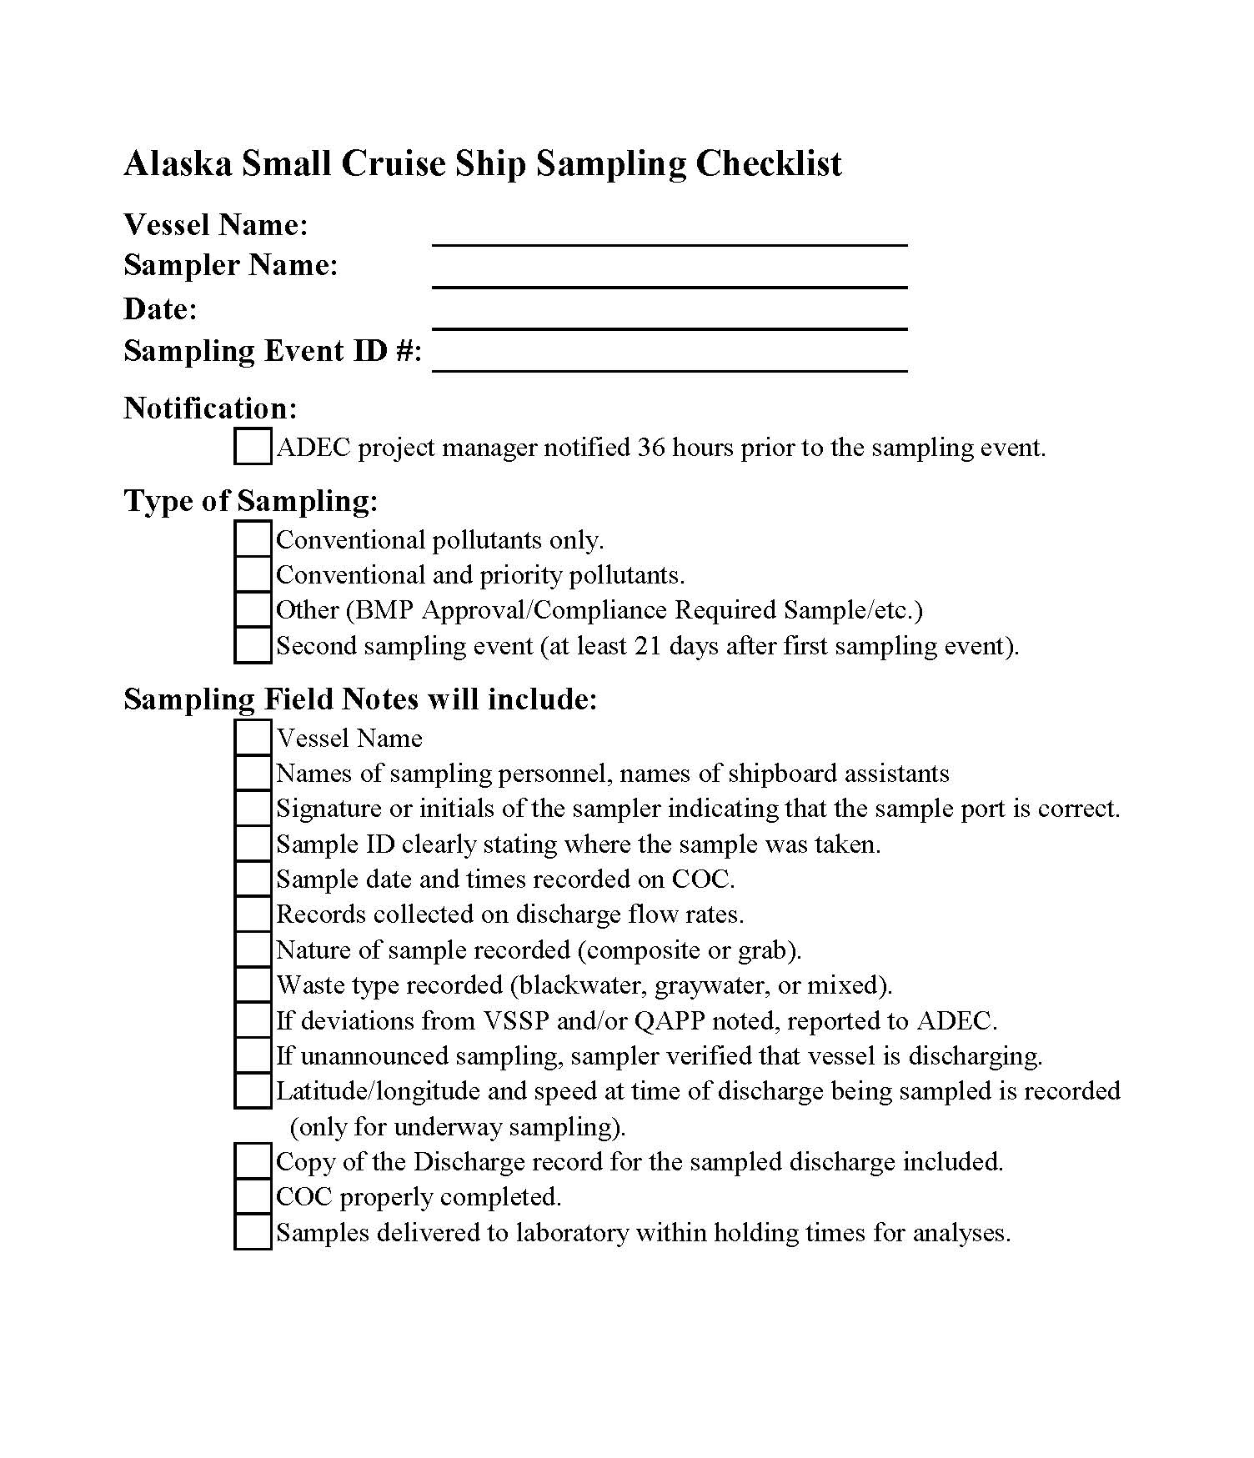

Appendix B - Alaska Small Cruise Ship Data Review Checklist
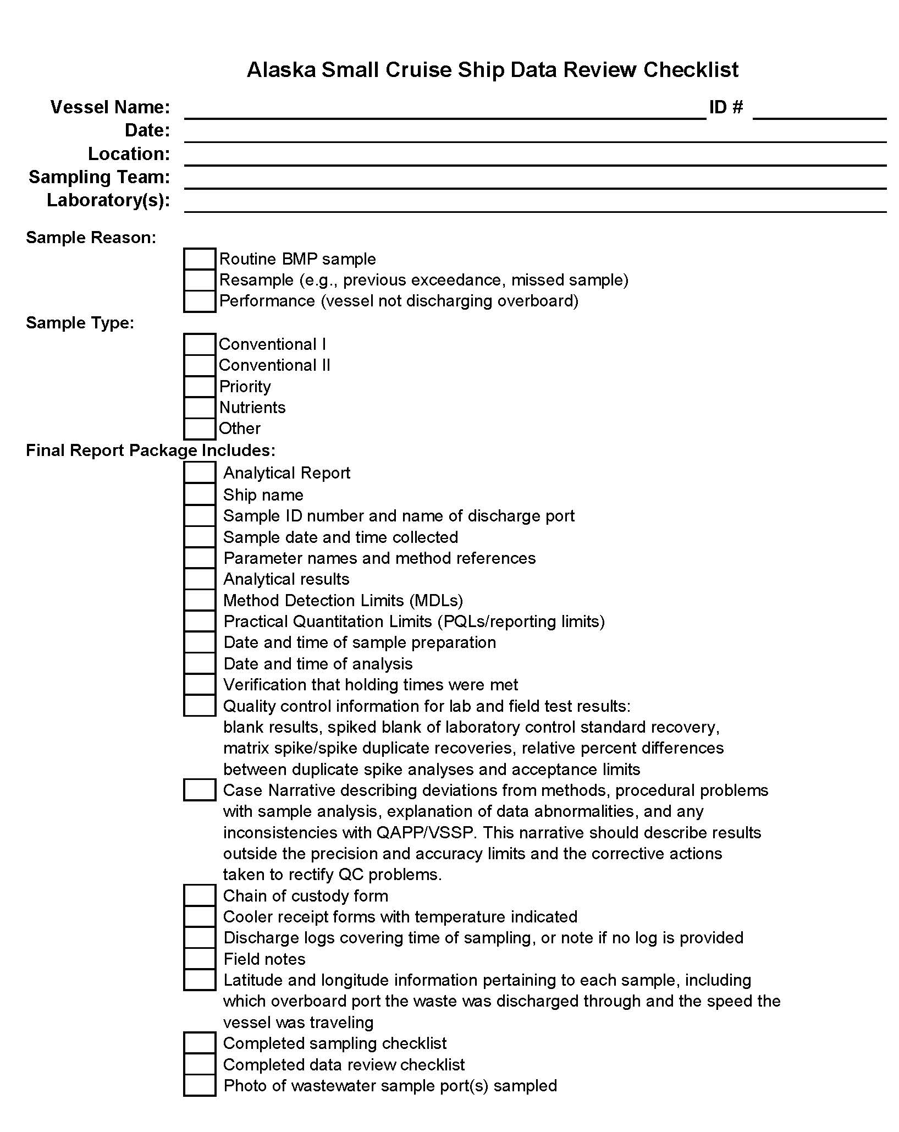

Appendix C – QAPP Deadlines*

*Please Note- these deadlines can change due to regulatory or statute changes. Please consult the latest ADEC regulations.

Applications:
QAPP: March 1st
VSSP: 21 days before sampling (ADEC). Preferable to provide VSSP application well in advance of this date, this to allow for ADEC CPVEC staff adequate review time.
Sampler qualifications: 21 days before sampling.

Notifications:
Deviations from VSSP: Immediately.
Deviations from BMP Plan: Immediately.
Sample Event- 36 hours prior.
Audit event: 36 hours prior.
Errors noted by lab or samplers: 7 days
Non-Compliance: within 24 hours of discovery.
Actions taken by the vessel to avoid re-occurrence: immediately after discovery / See BMP plan.

Analytical Reports:
21 days after completion of lab analysis.

Audits
Initial audit: Within 30 days of project initiation.
Second audit: Midway through the project.

Reporting:
Sampler training/certification information: when requested.
Sample scheduling, date, time, and location. At the beginning of the season
Sample Value exceedance: Report immediately when discovery notification of the lab. See BMP procedure.
Field instruments calibration and certification: Due May 31st and July 31st.
Audit reports due within 14 days. Draft reports are due with 7 days.
Technical laboratory audits: Draft due 1-2 weeks of end audit, final due 2-4 weeks of end audit.
First data review: Due by June 15th
Other data reviews: equally spaced through the season
Data review with problems noted: Immediately notify & submit report within 40 days of sample event

The VSSP for each vessel will list the proper location and timing of wastewater sampling. The samples will be taken in a manner that seeks to capture a typical wastewater discharge while still meeting the fecal coliform 6-hour holding time.
http://www.dec.state.ak.us/water/wqsar/wqs/index.htm
http://www.epa.gov/fedrgstr/EPA-WATER/2007/March/Day-12/w1073.htm

